TM Forum Open APIs
Conformance Certification

Company Name: Jio Platforms Limited

TM Forum Open API Name:
TMF641 Service Ordering Management

TM Forum Open API Release Version: 21.0 / 4.1

Report Date: 26-Sep-2021

- What Product or Solution does your API support?

The Jio OSS Fulfilment Management System Platform (OSS FMS) is a next generation workflow orchestration, provisioning, and activation platform. Apart from this, the platform also includes ‘Unified Inventory Management’ (UIM). This 5G Ready Fulfilment Management System comes with features such as Micro Service Based, Multi Cloud, LoB Agnostic, Open APIs, and Containers which help to create a frictionless digital service delivery by readily accelerating time to market.

- Overview of Certified API

Service Ordering Management

This API is implemented to provide a consistent/standardized mechanism to query and manipulate the Service inventory. It provides functionalities to establish, manage and administer the enterprise's service inventory stored in the Inventory Database, additionally it facilitates the usage monitoring of service inventory.

The following features are well supported by the Service Ordering Management API:
- Service Order Creation
- Service Order Deletion
- Service Order Update
- Service Order View for status check
- Service Order Cancellation
- Service Order state change notification to the user
- Service Order Pause/ Resume

- Architectural View

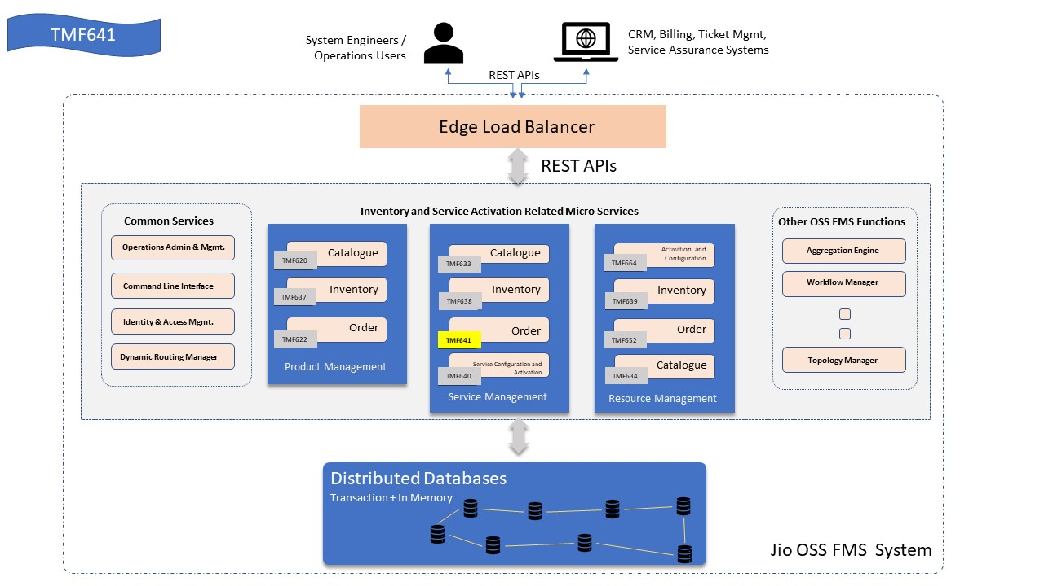

- Test Results

