TM Forum Open APIs
Conformance Certification

Company Name: Jio Platforms Limited

TM Forum Open API Name:
TMF642 Alarm Management

TM Forum Open API Release Version: 21.5 / 4.0

Report Date: 26-Sep-2021

- What Product or Solution does your API support?

Jio Network Management System (NMS) is a critical piece in the overall telecommunications-management solution. It is the sole mediator for monitoring and managing the FCAPS data of the network elements and provides a single pane of glass for the Network Operations Centre. It is fully integrated with AI and ML capabilities, leading to “light touch” operations. This cloud native and 5G ready management system comes with features such as Micro service based, Multi cloud, Unified, Standard compliant and Containers with an interactive user interface for smooth accessibility and visualization of the various functions it brings to the market.

- Overview of Certified API

Alarm Management

This API is implemented to provide an aggregated view of all the alarms across the geography. These can be filtered based on OC, Circle, Severity, Cause, Time Duration etc. Alarm View with Variety of Sort / Filter Criteria includes views based on the profiles created by the users. In Alarm Report case, E-mail can be configured against the administrators and users to whom Daily Alarm Report has to be sent over mail. Alarms are raised to give information regarding occurrence of some event. The event may be some error condition or some event whose information should be displayed. When a fault or event occurs, a network component will send a notification in the form of Alarm.

The JioNMS platform seamlessly integrates with the JioATOM platform for alarm correlation and advanced analytics. This also helps to achieve closed loop automation in resolving issues across the network.

Alarm Management in integrated to support various fault management features such as the Ability to;

- Pull out fault details
- Provide Real Time Alarm View
- Fetch Alarm history
- Capture North Bound Integrations
- Provide Alarm Clearance
- Provide Alarm Enrichment
- Send Alarm Notification Support
- Carry Alarm Aggregation based on time interval
- Provide Alarms Archiving and Purging
- Enable/ Disable Audio Notifications

- Architectural View

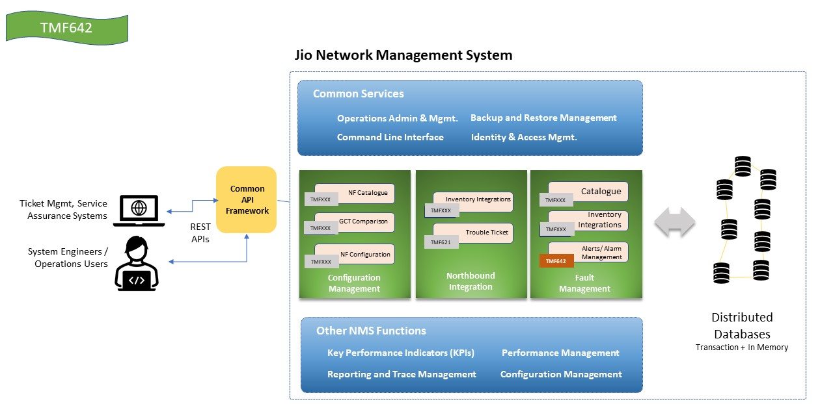

- Test Results

