TM Forum Open APIs
Conformance Certification

Company Name: Jio Platforms Limited

TM Forum Open API Name:
Quote Management API TMF648

TM Forum Open API Release Version: 19.0 / 4.0

Report Date: 26-Sep-2021

- What Product or Solution does your API support?

The Jio Product Catalogue helps create new products and services from reusable product, service and resource components. One can assemble offerings, drive sales and manage fulfillment processes with lower costs and better reliability. Product teams can define new product offerings and specifications quickly by leveraging pre-defined technical specifications and provisioning processes. Product Catalogue is used for provisioning of Reference Data Services like Tax Model, Discount, Geographic Location, Sales Channel and Plan Specification, Composite Price, Plan Offer Services with required mappings of these Services.

- Overview of Certified API

Quote Management

This API is implemented to provide a consistent/standardized mechanism to manage the quotes placed by a customer for any product or service. The quotes are analyzed based on the product offering defined in the catalog and that put forth by the customer based on the parameters of product pricing, product options and agreement with respect to product availability. This API includes the following operations with regards to a customer quote:

- Quote creation
- Quote update/ modification
- Quote viewing
- Quote deletion
- Quote notification of state change

- Architectural View

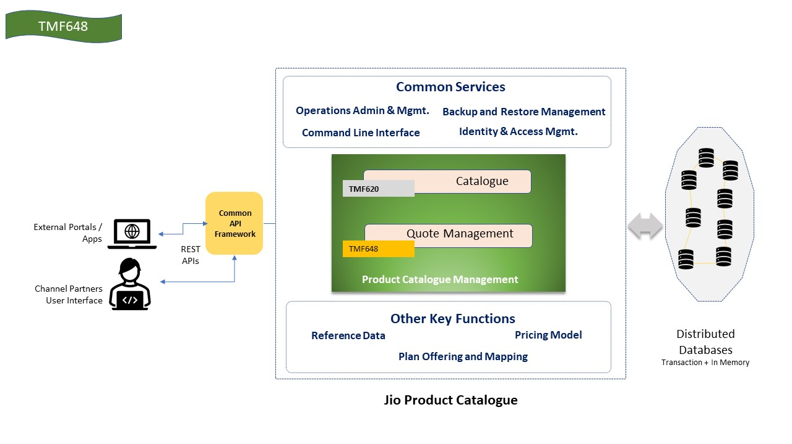

- Test Results

