TM Forum Open APIs
Conformance Certification

Company Name: Jio Platforms Limited

TM Forum Open API Name:
Resource Ordering Management TMF652

TM Forum Open API Release Version: 21.0 / 4.0

Report Date: 26-Sep-2021

- What Product or Solution does your API support?

The Jio OSS Fulfilment Management System Platform (OSS FMS) is a next generation workflow orchestration, provisioning, and activation platform. Apart from this, the platform also includes ‘Unified Inventory Management’ (UIM). This 5G Ready Fulfilment Management System comes with features such as Micro Service Based, Multi Cloud, LoB Agnostic, Open APIs, and Containers which help to create a frictionless digital service delivery by readily accelerating time to market

- Overview of Certified API

Resource Ordering Management

This API is implemented to provide a consistent/standardized mechanism to query and manipulate the Resource inventory. It provides functionalities to establish, manage and administer the enterprise's resource inventory stored in the Inventory Database, additionally it facilitates the usage monitoring of resource inventory.

The following features are well supported by the Resource Ordering Management API:

- Resource Order Creation
- Resource Order Deletion
- Resource Order Update
- Resource Order Cancellation
- Resource Order View for status check
- Resource Order state change notification to the user
- Resource Order Pause/ Resume

- Architectural View

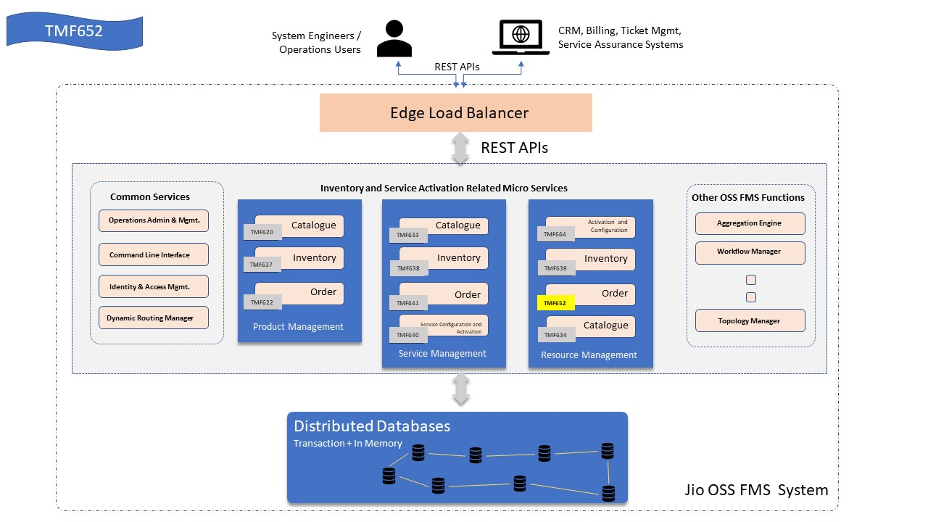

- Test Results

