TM Forum Open APIs
Conformance Certification

Company Name: Jio Platforms Limited

TM Forum Open API Name:
Prepay Balance Management API TMF654

TM Forum Open API Release Version: 20.5 / 4.0

Report Date: 26-Sep-2021

- What Product or Solution does your API support?

The JIO Total Charge is a complete charging solution of 2G/3G, 4G , 5G and IMS network. It fulfills the billing, invoicing, rating and statistics requirements of all types of services offered by an operator. The system is built using the state of the art techniques such as micro-service based, N-way active, resilient and DR support, dynamic service provisioning and processing, containerized etc. It can be deployed and integrated with any operator network seamlessly.

- Overview of Certified API

Prepay Balance Management

This API is implemented to take care of the sufficient balance for usage of customers opting for prepaid billing or purchasing that is paying for the opted services in advance before usage. This API keeps a track of the balance available to each customer by measuring it in units which might be monetary or non-monetary (such as in terms of data – GB, etc.) This API gives a functionality to pass on credit balances to make the services available to the customer in sufficient amount for a specified time period as per the opted subscription. The API is responsible to manage the following few usage cases:

- Keep a check on the balance of the resource
- Top Up or recharge functionalities
- Balance transfer requests and its functionalities
- Balance adjustment requests and its functionalities
- Balance reserve and unreserved services
- Balance deduction with respect to the usage and its requests

- Architectural View

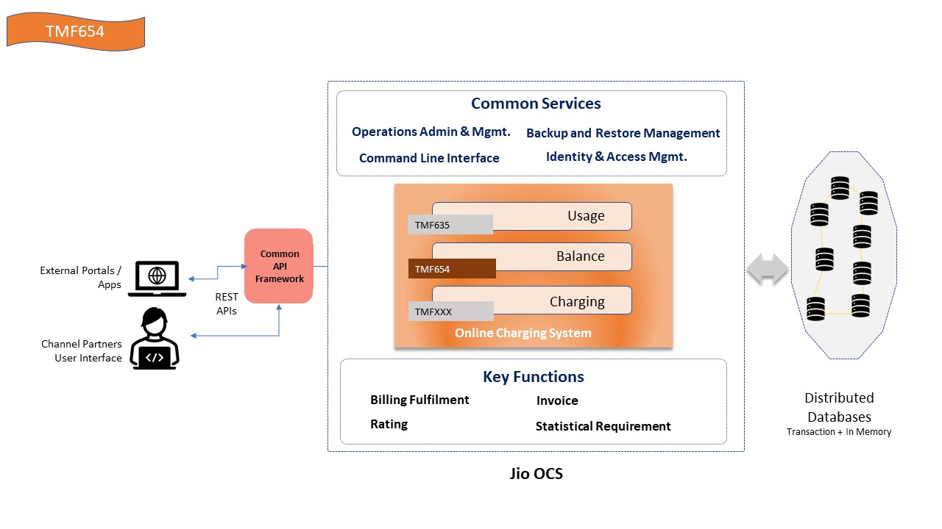

- Test Results

