TM Forum Open APIs
Conformance Certification

Company Name: Jio Platforms Limited

TM Forum Open API Name:
Payment Management API TMF676

TM Forum Open API Release Version: 20.5 / 4.0

Report Date: 26-Sep-2021

- What Product or Solution does your API support?

Jio’s Converged Subscription, Marketplace and CRM Lite Solution is a micro service-based solution with multi cloud deployment support. It also provides Open API based integrations with other solutions in the ecosystem.

Amongst the various solutions, this API supports the Jio Subscription Marketplace Platform which acts as a UI interface to consumers and businesses to browse, buy and sell products. It allows the user to select a payment plan and do the payment for his subscription in recurring manner based on the usage of the product. This helps to eliminate the usage related problems associated with subscription-based business models. All the plans and billing details of the user based on their subscription is available in the portal. All subscription specific events are routed to respective content platform, and is determined based on the platform type, for provisioning.

Jio Marketplace provides a highly reliable, scalable, secure and easy to use platform. The platform has been designed based on micro services architecture with a flexibility to deploy all micro services on bare metal, as virtual machine or as containers. The solution allows an individual micro service to be scaled as per the capacity requirement. The platform is designed to provide high performance and throughputs.

- Overview of Certified API

Payment Management

This API is implemented to provide a user interface for Payment Page. The subscribed users can view the payment page with the plan summary to proceed with the billing based on the subscription. In plan summary, user can edit the quantity of add-ons if user has access to change or else default quantity will be 1. After successful payment, the user is navigated to subscription confirmation page. The payment management page navigates to the desired payment gateway selected by the user with respect to the items billed through the shopping cart.

- Architectural View

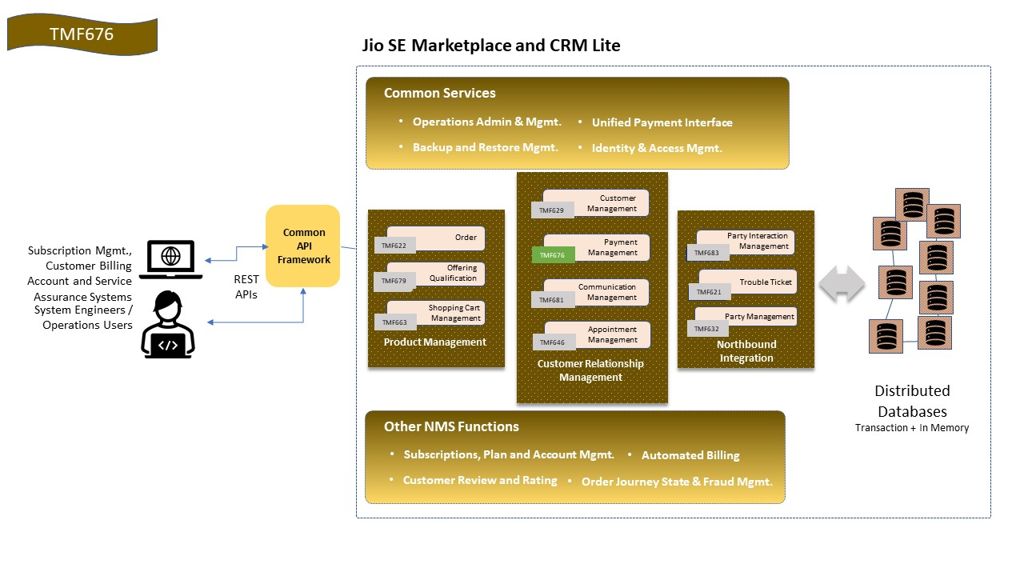

- Test Results

