TM Forum Open APIs
Conformance Certification

Company Name: Jio Platforms Limited

TM Forum Open API Name:
Product Offering Qualification API TMF679

TM Forum Open API Release Version: 19.0 / 4.0

Report Date: 26-Sep-2021

- What Product or Solution does your API support?

Jio’s Converged Subscription, Marketplace and CRM Lite Solution is a micro service-based solution with multi cloud deployment support. It also provides Open API based integrations with other solutions in the ecosystem.

Amongst the various solutions, this API supports the Jio CRM Lite which helps to store Enterprise Customer details and enables easy integration with Jio OSS FMS. It stores the state of customer order journey which helps the customer track the order status. This includes the model definition as well as available operations. The possible actions are creating, updating and retrieving individuals or organizations including filtering option. The custom milestones can be created in the order completion journey. CRM Lite also integrates with OSS FMS to provision the devices according to the order submitted by the customer. It enables construction of unique and personalized customer relations CRM Lite also provides superior services, respond promptly to incoming orders and inquiries, and include personalized products in your offer thanks to a complete 360-degree customer view run in real time and always in context. The Party is created to record an individual or an organization before the assignment of any role.

- Overview of Certified API

Product Offering Qualification

This API is implemented to provide a systematic mechanism in order to place a request for a qualification check on the offer provided against a product in order to test its commercial capability by ticking all the applicable parameters in view. This API holds responsibility in the pre-order confirmation phase by checking and managing the following points:
- Request for the eligibility of a specific product offering
- Scrutinize the product offering eligibility across different categories of a product
- Specify the reason in case the request for a product offering is ineligible or cannot be qualified
- Put forward an alternate qualifying approach near to the proposed product offering

- Architectural View

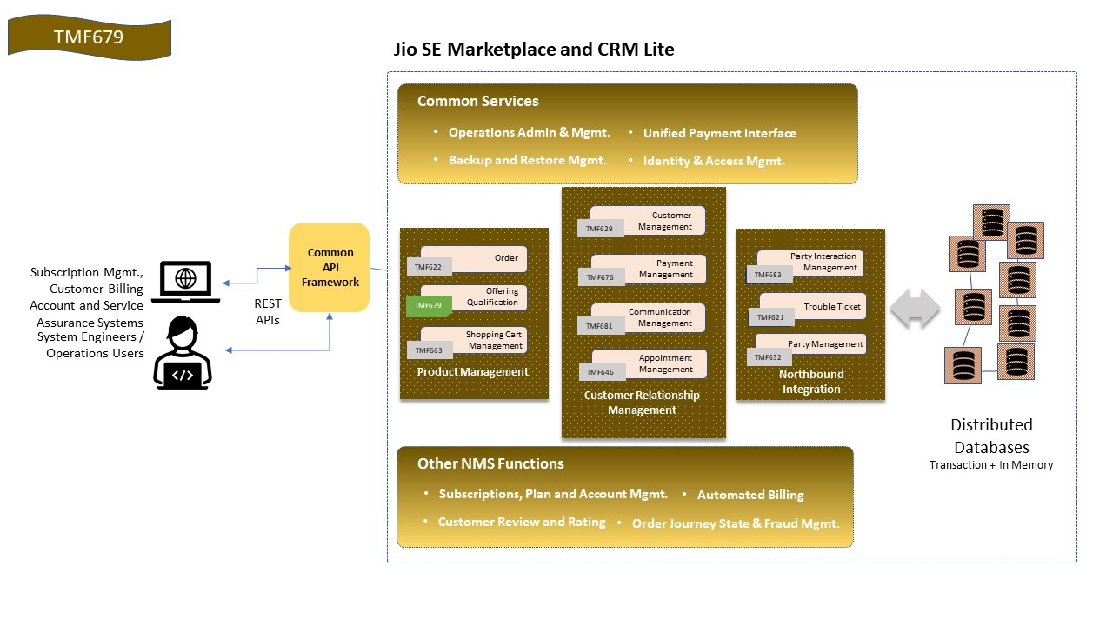

- Test Results

