TM Forum Open APIs
Conformance Certification

Company Name: Jio Platforms Limited

TM Forum Open API Name:
Communication API TMF681

TM Forum Open API Release Version: 20.5 / 4.0

Report Date: 26-Sep-2021

- What Product or Solution does your API support?

Jio’s Converged Subscription, Marketplace and CRM Lite Solution is a micro service-based solution with multi cloud deployment support. It also provides Open API based integrations with other solutions in the ecosystem.

Amongst the various solutions, this API supports the Jio CRM Lite which helps to store Enterprise Customer details and enables easy integration with Jio OSS FMS. It stores the state of customer order journey which helps the customer track the order status. This includes the model definition as well as available operations. The possible actions are creating, updating and retrieving individuals or organizations including filtering option. The custom milestones can be created in the order completion journey. CRM Lite also integrates with OSS FMS to provision the devices according to the order submitted by the customer. It enables construction of unique and personalized customer relations CRM Lite also provides superior services, respond promptly to incoming orders and inquiries, and include personalized products in your offer thanks to a complete 360-degree customer view run in real time and always in context. The Party is created to record an individual or an organization before the assignment of any role.

This API also supports the Jio Subscription Marketplace Platform solution; which acts as a UI interface to consumers and businesses to browse, buy and sell products. It allows the user to select a payment plan and do the payment for his subscription in recurring manner based on the usage of the product. This helps to eliminate the usage related problems associated with subscription-based business models. All the plans and billing details of the user based on their subscription is available in the portal. All subscription specific events are routed to respective content platform, and is determined based on the platform type, for provisioning.

Jio Marketplace provides a highly reliable, scalable, secure and easy to use platform. The platform has been designed based on micro services architecture with a flexibility to deploy all micro services on bare metal, as virtual machine or as containers. The solution allows an individual micro service to be scaled as per the capacity requirement. The platform is designed to provide high performance and throughputs.

- Overview of Certified API

Communication API Rest Specification

This API is implemented to provide a systematic mechanism for the management of communication events carried out by a system. This aims at sending/ receiving communication messages to a customer. This communication is either carried by a text message or an email notification. Communication refers to a meaningful interaction with a customer in regards to a product or a service offered/ used that is meaningful and constitutes to the resolution of a certain query/ issue. This API performs the following operations with respect to communication messages:
- Create a message
- Update/ modify a message
- Delete a message
- View a message
- Send a message
- Message Notifications

- Architectural View

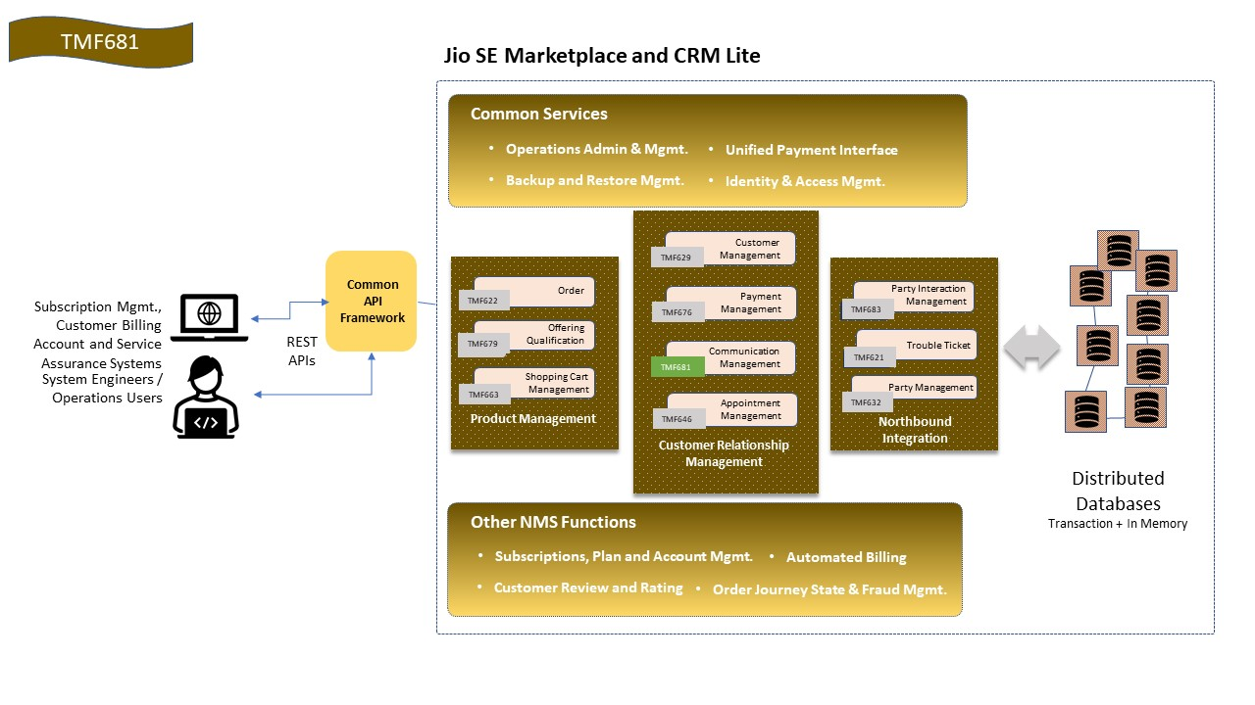

- Test Results

