TM Forum Open APIs
Conformance Certification

Company Name: Jio Platforms Limited

TM Forum Open API Name:
Party Interaction Management API TMF683

TM Forum Open API Release Version: 20.5 / 4.0

Report Date: 26-Sep-2021

- What Product or Solution does your API support?

Jio’s Converged Subscription, Marketplace and CRM Lite Solution is a micro service-based solution with multi cloud deployment support. It also provides Open API based integrations with other solutions in the ecosystem.

Amongst the various solutions, this API supports the Jio CRM Lite which helps to store Enterprise Customer details and enables easy integration with Jio OSS FMS. It stores the state of customer order journey which helps the customer track the order status. This includes the model definition as well as available operations. The possible actions are creating, updating and retrieving individuals or organizations including filtering option. The custom milestones can be created in the order completion journey. CRM Lite also integrates with OSS FMS to provision the devices according to the order submitted by the customer. It enables construction of unique and personalized customer relations CRM Lite also provides superior services, respond promptly to incoming orders and inquiries, and include personalized products in your offer thanks to a complete 360-degree customer view run in real time and always in context. The Party is created to record an individual or an organization before the assignment of any role.

- Overview of Certified API

Party Interaction Management

This API is implemented to provide a systematic mechanism for the management of party interaction that is any form of engagement between a customer and the service provider. This may be in the form of online customer services that is calling or messages, in person store visits or online shopping using websites or apps. This also includes interaction carried out by the companies in the form of promotional messages, offer suggestions, notifications regarding its products, services and more. This includes operations such as creation, update or modification and deletion of any such interactions taken place.

- Architectural View

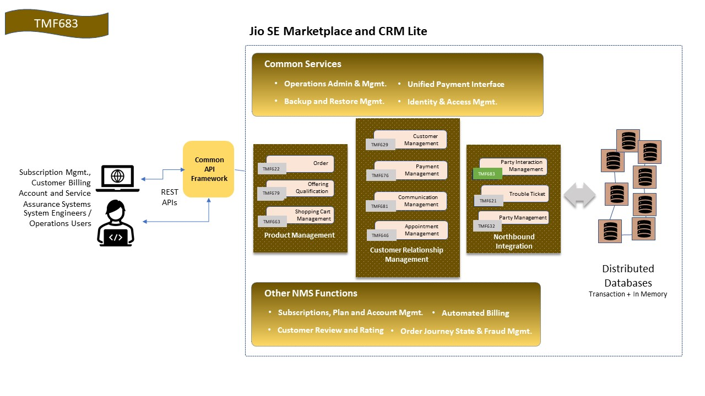

- Test Results

