TM Forum Open APIs
Conformance Certification

Company Name: Netcracker - NEC

TM Forum Open API Name:
Account Management API TMF666

TM Forum Open API Release Version: 19.0 / 4.0

Report Date: 20-October-2021

- What Product or Solution does your API support?
Netcracker’s Industry leading BSS/OSS solutions have globally enabled over 250 customers in their journey towards Business and Digital transformation. Netcracker leverages its comprehensive experience in transformation methodology and technologies in order to provide business value to its customers. With a BSS/OSS suite of products and technologies, that is complaint with Industry Standards, Netcracker provides a distinct advantage to its customers in their transformation journey.

Following is Netcracker Product portfolio, a complete BSS/OSS suite with the Digital BSS Integration Layer marked to show the relevance of this API being supported:

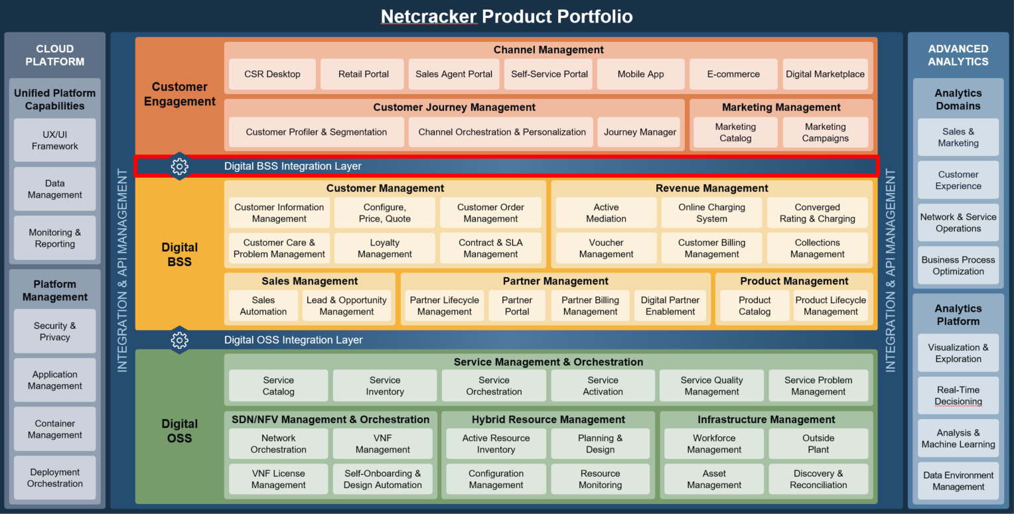

Netcracker’s approach to integration focuses on standardization, automation, and reuse. It offers a rich unique know-how toolset, and a wide set of out-of-box connectors and pre-configured adapters. It supports a variety of integration types and techniques, including streaming, database, API-based and others. The solution spans integration cases across BSS/OSS and reduces the complexity during implementation. Netcracker modules, integration tools and methodologies comply with key industry standards, including TMF Open API, REST, MEF, ETSI, 3GPP. Access control, subscription and API management and monitoring are available to closely monitor system operation and integration process.
Netcracker’s Digital BSS Integration Layer help service providers to:

  - Provide business units with capabilities to make changes without affecting IT operations.
  - Increase competitiveness through the accelerated deployment of new applications to satisfy market demand.
  - Introduce new services faster by rapidly onboarding and integrating partners.
  - Introduce new business models through network and BSS/OSS data monetization.
  - Bring diverse, third-party cloud and virtualized services to market.
  - Enable IoT initiatives with integration capabilities for diverse device and application ecosystems.

- Overview of Certified API

TMF666 “Account Management” API has been implemented as a part of Netcracker’s CloudBSS Solution Suite and it is fully compliant with Release 19.0.1 of the API specification.
The API has been self-certified in a controlled test environment within Netcracker.

- Architectural View
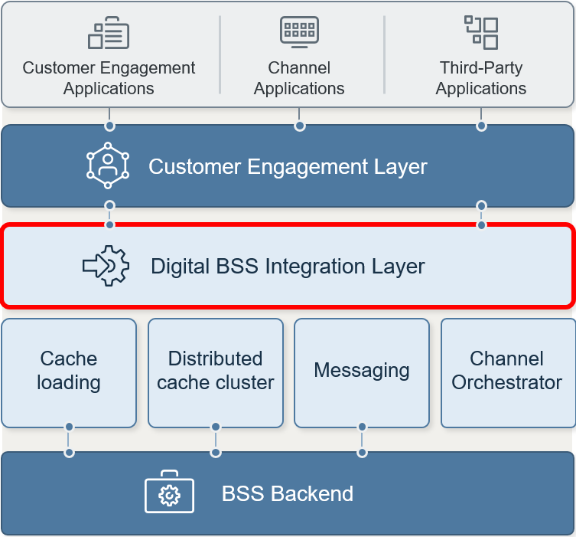
Digital BSS Integration Layer provides abstraction of the customer engagement layer from the core BSS for agile business operations.

It delivers high-level, standards-compatible and tested APIs on top of BSS. The support of high availability requirements guarantees business continuity for all critical functions. The integrations feature advanced security including ABAC authorization and support of GraphQL to build client driven requests. The solution is ready for omni-channel environments and is easy to use for 3rd party developers.
Digital OSS Integration Layer delivers smooth integration in many directions:
  - northbound – with BSS,
  - southbound – with network,
  - and sideways with ERP, finance and other administrative tools.
It provides library of APIs, including REST, SOAP and fully supports TOSCA, Netconf/YANG. The solution delivers an OOB set of best practices and templates for a variety of integration channels, including modern ones like REST TMF-6xx/8xx, NETCONF, RESTCONF, as well as traditional ones: JDBC, LDAP, SNMP, WebDAV, FTP (TFRP, TFTP, FTPS), CLI (Telnet, SSH), RMI/EJB, CORBA, Web-Services. It is pre-integrated with Self-Onboarding and Design Automation allowing for optimized integration management.
- Test Results

