**TM Forum Open APIs**

**Conformance Certification**

*Company Name:* ***Tata Consultancy Services***

*TM Forum Open API Name:*

***Product Catalogue Management - TMF620***

*TM Forum Open API Release Version:* ***21.0 / 4.1***

**Report Date: 05 October, 2021**

1. **What Product or Solution does your API support?**

TCS HOBS is a platform for new age digital services as well as traditional telco services. The cloud-ready platform is secure and scalable. It covers key business processes across multi-channel engagement, product management, selling, assurance, revenue management, partner management, and enterprise management. Our platform is catalog-centric, metadata-driven, and modular, which helps companies leverage modules and capabilities, based on business requirements

1. **Overview of Certified API**

Product Portfolio Management System (PPMS) supports the Product Lifecycle Management and Product/Service business capabilities which enables service providers to introduce New Products and manage the current product portfolio efficiently. This API allows to create, find and retrieve catalogue entities such as ProductSpecification, ProductOffering and ProductOfferingPrice. This API enables us to retrieve the orderable entity from the provider of the catalog.

1. **Architectural View**

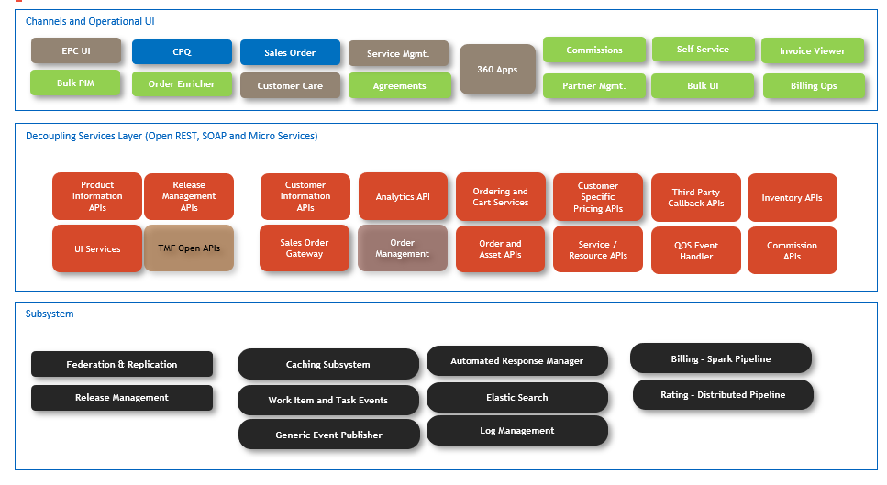

1. **Test Results**

