**TM Forum Open APIs**

**Conformance Certification**

*Company Name:* ***Tata Consultancy Services***

*TM Forum Open API Name:* ***Shopping-Cart- TMF663***

*TM Forum Open API Release Version:* ***20.5 / 4.0***

**Report Date: 07/10/2021**

1. **What Product or Solution does your API support?**

TCS HOBS is a platform for new age digital services as well as traditional telco services. The cloud-ready platform is secure and scalable. It covers key business processes across multi-channel engagement, product management, selling, assurance, revenue management, partner management, and enterprise management. Our platform is catalog-centric, metadata-driven, and modular, which helps companies leverage modules and capabilities, based on business requirements

1. **Overview of Certified API**

The Shopping Cart API provides a standardized mechanism for the management of shopping carts. Including creation, update, retrieval, deletion and notification of event. Shopping Cart entity is used for the temporarily selection and reservation of product offerings in e-commerce and retail purchase. Shopping cart supports purchase of both tangible and intangible goods and service (e.g. handset, telecom network service). The charge includes the one-off fee such as the fee for handset and the recurring fee such as the fee of a network service. Shopping Cart contains list of cart items, a reference to party or party role (e.g. customer) or contact medium in case of unknown customer, In addition the calculated total items price including promotions.

1. **Architectural View**

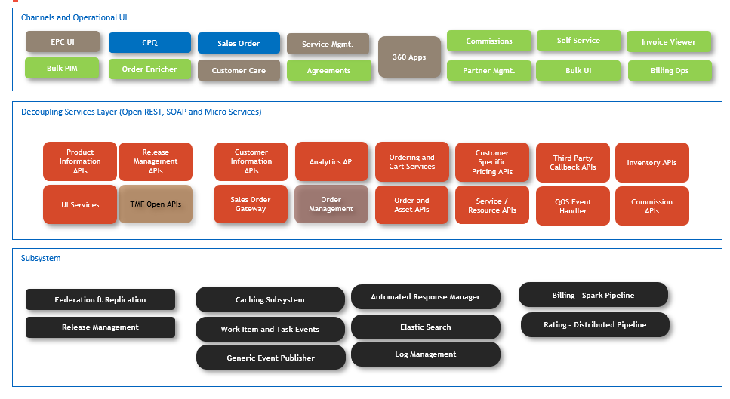

1. **Test Results**

