TM Forum Open APIs
Conformance Certification

Company Name: Tata Consultancy Services

TM Forum Open API Name:
Party Role Management – TMF669

TM Forum Open API Release Version: 19.0 / 4.0

Report Date: 12-OCT-2021
- What Product or Solution does your API support?

TCS HOBS is a platform for new age digital services as well as traditional telco services. The cloud-ready platform is secure and scalable. It covers key business processes across multi-channel engagement, product management, selling, assurance, revenue management, partner management, and enterprise management. Our platform is catalog-centric, metadata-driven, and modular, which helps companies leverage modules and capabilities, based on business requirements

- Overview of Certified API

The party role management API provides a list of APIs to associate a party with different roles and also provides additional APIs to update, search and delete the associations. The current API implementation covers the following scenarios.

Operation On Entity | API Operation | Description
Create Entity | POST Resource | Create a new resource
Query Entity | GET Resource | Retrieve the resource using mandatory filters and/or fields
Partial Update of an Entity | PATCH Resource | Partially update the resource
Remove Entity | DELETE Resource | Delete API is used to remove an entity

- Architectural View

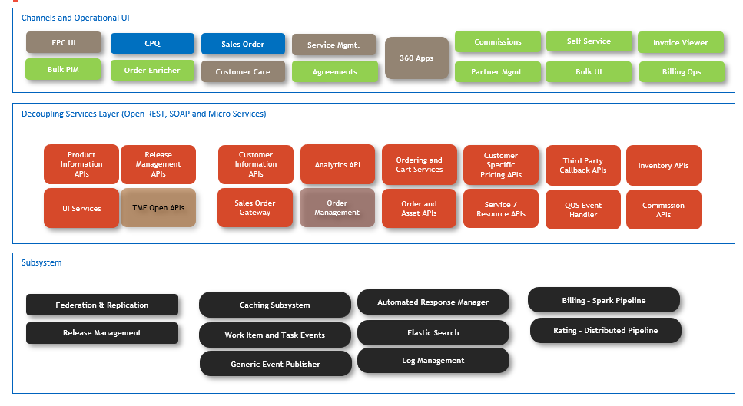

- Test Results

