TM Forum Open APIs
Conformance Certification

Company Name: Pega

TM Forum Open API Name:
Product Catalog Management API TMF620

TM Forum Open API Release Version: 21.0 / 4.1

Report Date: 06 October 2021

- What Product or Solution does your API support?

For customer experience leaders, the days of reactive service are long gone. Instead, today’s world is digital and proactive – your customers expect frictionless service on whatever device is closest to them. In fact, Gartner predicts that by 2022, the majority (70 percent) of all customer interactions will involve digital channels – including messaging, live chat, and chatbots. The race to digital transformation starts with a balanced, customer-centric strategy to differentiate and retain your most valued clients.

The Pega InfinityTM Digital Transformation Suite helps drive this effort with AI-powered customer engagement and end-to-end robotic automation. These capabilities are designed to fuel personalized interactions and streamlined service journeys across your entire enterprise. Pega empowers large organizations to:

- Increase customer satisfaction and customer engagement - Guide the user throughout the entire journey on either assisted or self-service channels – so that conversations are simple, productive, and consistent.
- Make agents more productive - Accelerate agent productivity with contextual knowledge content to provide a personalized service experience, solving customer issues quickly – and accurately.
- Drive greater revenue and retention - Guide agents in real time with contextual recommendations using next best actions for the right offer or best retention strategy meeting each individual circumstance.

The Key capabilities of the solution are:
- Real-time, omni-channel AI: Deliver consistent and personalized customer service experiences across phone, web, email, chat, and more without losing the context of the conversation.
- AI-guided interactions: Pega’s AI-Augmented agent capability learns from your top agents for optimal next-best-action guidance.
- Dynamic case management: Connect people, contact center systems, and processes for end-to-end visibility and resolution.
- Contextual digital self-service: Make your website experiences more effective by infusing context with personalized offers for increased customer engagement.
- Robotic desktop automation: Optimize and automate mundane processes with a personal robot. These are available for every agent.
- Chatbots and virtual assistants: Deploy conversational interfaces and AI-powered email to speed up responses using Pega’s Intelligent Virtual Assistant.
- Integrated computer telephony integration (CTI): Personalized screen pops within the agent desktop using Pega Call TM
- Knowledge management, communities, and troubleshooter: Support for curated articles, discussion groups, and troubleshooting.
- Real-time co-browse: Share the same webpage with just a single click. This can be done between two or more parties.
- Web/mobile mashup: Embed self-service options throughout your customer journey.
- Personalized desktop with industry views: Adapt to each customer need across multiple vertical industries.

- Overview of Certified API

Pega Product Catalog for Communications APIs provide a standardized solution to add partners, integrate with other solutions and reduce time to value.

Here is the list of API and actions available through TMF620 API :

Resource | Description | Operations
Product Offering | Product Offering API is used to create, update or list Product Offers in the system. These offers are available to customers in market. | - Get  - List  - Post  - Patch  - Delete
Product Specification | Product Specification API is used to create, update or list tangible products or intangible goods that service provider wants to sell in the market. | - Get  - List  - Post  - Patch  - Delete
Product Offering Price | Product Offering Price API is used to create / update or list price for an offer. | - Get  - List  - Post  - Patch  - Delete

- Architectural View

Pega Customer Engagement Solution for Comms

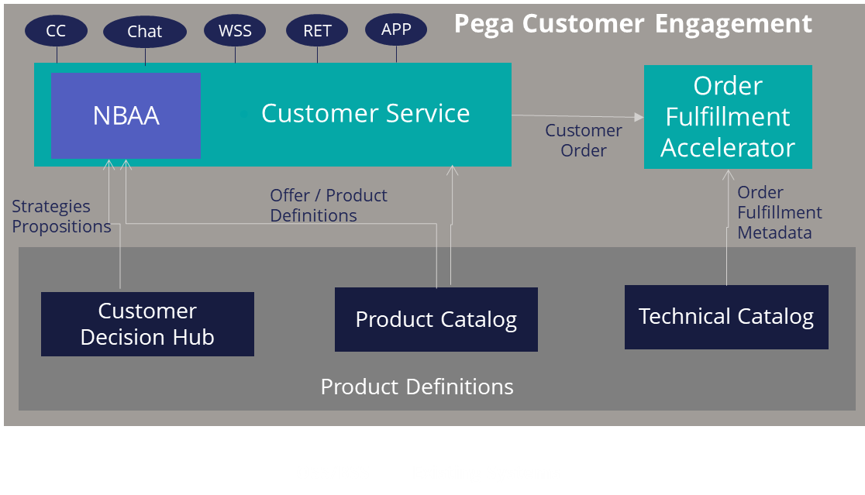

- Test Results

