TM Forum Open APIs
Conformance Certification

Company Name: Aria Systems Inc.

TM Forum Open API Name:
TMF622 Product Ordering API

TM Forum Open API Release Version: 19.0 / 4.0

Report Date: 08-Nov-2021

- What Product or Solution does your API support?

This API is designed to support Aria’s flagship billing and monetization platform. It is a cloud-native order-to-usage-to-cash solution that is designed to interoperate with a CSP’s IT eco-system using over 360 APIs as end-to-end autonomous billing operation.

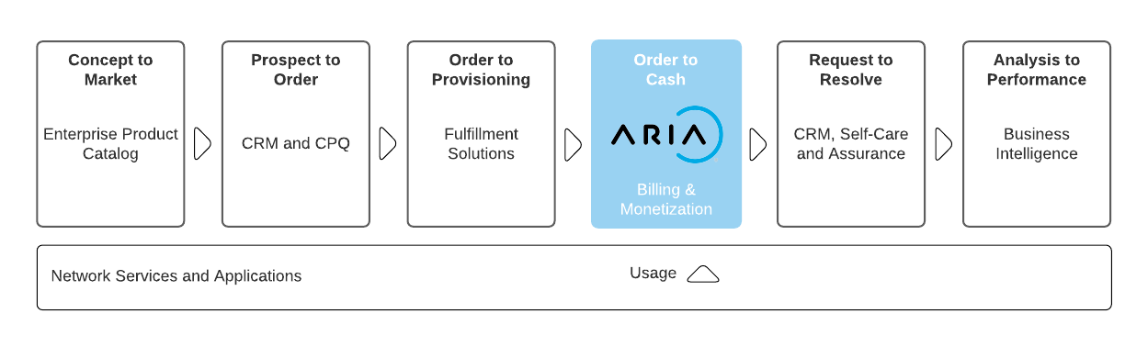
Aria is committed to complying with the TM Forum’s Open API & Open Digital Architecture (ODA) model. It reduces integration costs and timelines for CIOs/CTOs who are actively shifting course to build a more flexible architectural foundation for opportunities driven by 5G/SDN, partnerships and new best-of-breed systems of engagement.

Aria:
- Replaces or augments traditional and best-of-suite operational and business support system (OSS/BSS) architectures that restrict business agility.

- Is 100% configurable (no-code platform) enabling business and IT leaders to get to market fast and at lower cost to entry.

- Operates at web scale and leverages public cloud to change the billing relationship with features such as real-time billing, payment automation and AI/ML routine ingestion to improve time-to-cash and revenue assurance.

- Supports over 100 large CSPs and enterprises across multiple industry verticals, proving it can bill and monetize for any product, for any segment via any channel.

- For more information on Aria for Communication, see https://bit.ly/3FcjDgv

- Overview of Certified API

TMF622 - Product Ordering API provides a standardized mechanism for placing a product order with all the necessary order parameters on Aria Crescendo. A product order is created based on a product offer and product specifications that are defined in a catalog. The product offer identifies the product or set of products that are available to a customer, and includes characteristics such as pricing, product options and market.

The Table below show the API mandated resource along with mandated operations for conformance.
ProductOrder
Operation | Mandatory/Optional | Comments
GET | M | Response Status Code 200 if successful  Response Status Code 404 if not found
POST | M | Status Code 201 if resource created

ProductOrder Operations

- Create a product order
  - This operation creates a product order within Aria Crescendo
- Retrieve product orders
  - This operation retrieves a list product orders from Aria Crescendo
- Retrieve product order by filters
  - This operation retrieves a product or products based on a variety of filter conditions from Aria Crescendo

- Architectural View

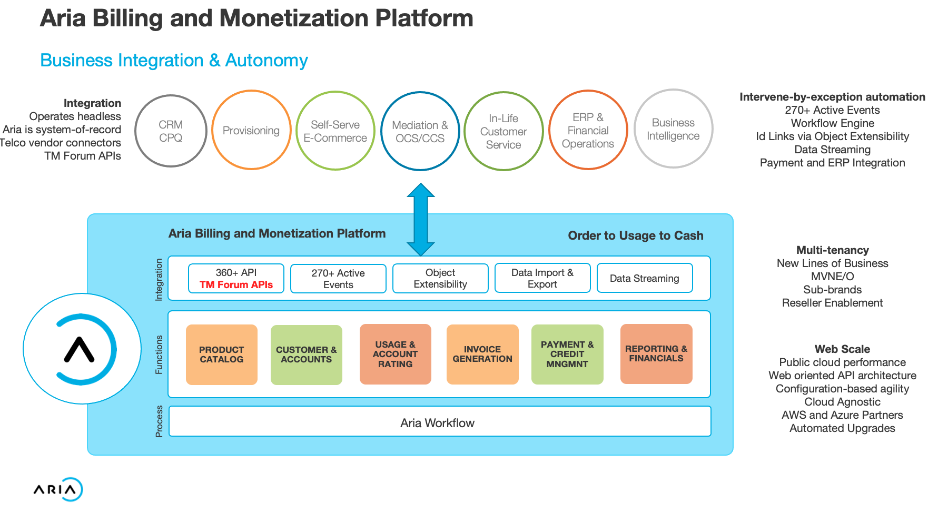

- Test Results

