TM Forum Open APIs
Conformance Certification

Company Name: Aria Systems Inc.

TM Forum Open API Name:
TMF629 Customer Management API

TM Forum Open API Release Version: 19.0 / 4.0

Report Date: 18-Nov-2021

- What Product or Solution does your API support?

This API is designed to support Aria’s flagship billing and monetization platform. It is a cloud-native order-to-usage-to-cash solution that is designed to interoperate with a CSP’s IT eco-system using over 360 APIs as end-to-end autonomous billing operation.

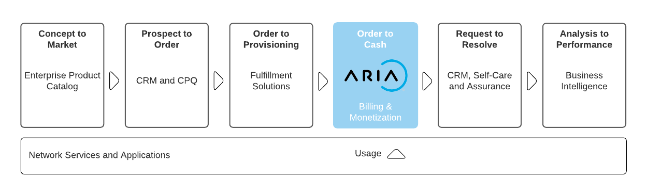
Aria is committed to complying with the TM Forum’s Open API & Open Digital Architecture (ODA) model. It reduces integration costs and timelines for CIOs/CTOs who are actively shifting course to build a more flexible architectural foundation for opportunities driven by 5G/SDN, partnerships and new best-of-breed systems of engagement.

Aria:
- Replaces or augments traditional and best-of-suite operational and business support system (OSS/BSS) architectures that restrict business agility.

- Is 100% configurable (no-code platform) enabling business and IT leaders to get to market fast and at lower cost to entry.

- Operates at web scale and leverages public cloud to change the billing relationship with features such as real-time billing, payment automation and AI/ML routine ingestion to improve time-to-cash and revenue assurance.

- Supports over 100 large CSPs and enterprises across multiple industry verticals, proving it can bill and monetize for any product, for any segment via any channel.

- For more information on Aria for Communication, see https://bit.ly/3FcjDgv

- Overview of Certified API

TMF629 - Customer Management API provides:

- a standardized mechanism for customer and customer account management such as creation, update, and retrieval in Aria Crescendo.
- allows the management of both financial and identification information about the Customer.

In its simplest form a customer represents a person or organization that buys products and services from the enterprise or receives free offers or services. More complex forms of a customer include, but not limited to, other service providers, who resell the enterprises products, or that lease the enterprise's resources for utilization by the other service provider's products and services.

The Table below show the API mandated resource along with mandated operations for conformance.
Customer
Operation | Mandatory/Optional | Comments
GET | M | Response Status Code 200 if successful  Response Status Code 404 if not found
POST | M | Status Code 201 if resource created
PATCH | M | Status Code 201 if resource created

    - Customer Operations
- Create Customer
  - This operation creates a customer within Aria Crescendo
- Update Customer
  - This operation updates a customer in Aria Crescendo
- Retrieve Customer
  - This operation retrieves a list of customers from Aria Crescendo
- Retrieve Customer by filters
  - This operation retrieves a customer or customers based on a variety of filter conditions from Aria Crescendo
- Architectural View

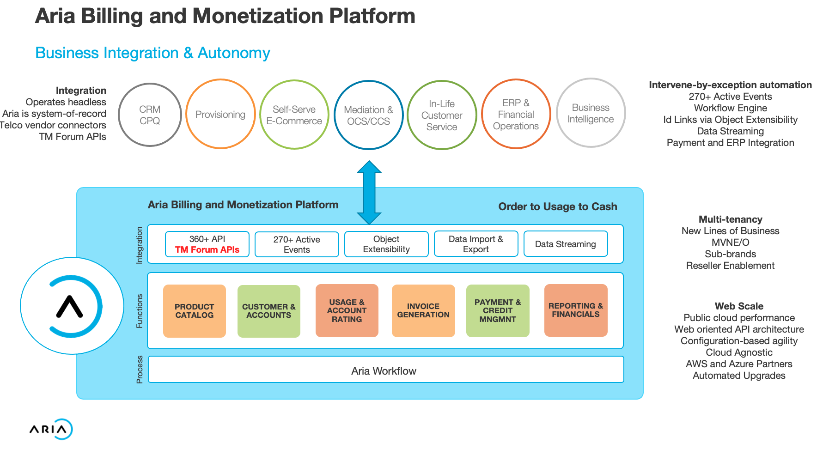

- Test Results

TMF629 HTML Results

