s
TM Forum Open APIs
Conformance Certification

Company Name: Aria Systems Inc.

TM Forum Open API Name:
TMF635 Usage Management API

TM Forum Open API Release Version: 20.5 / 4.0

Report Date: 12-Nov-2021

- What Product or Solution does your API support?

This API is designed to support Aria’s flagship billing and monetization platform. It is a cloud-native order-to-usage-to-cash solution that is designed to interoperate with a CSP’s IT eco-system using over 360 APIs as end-to-end autonomous billing operation.

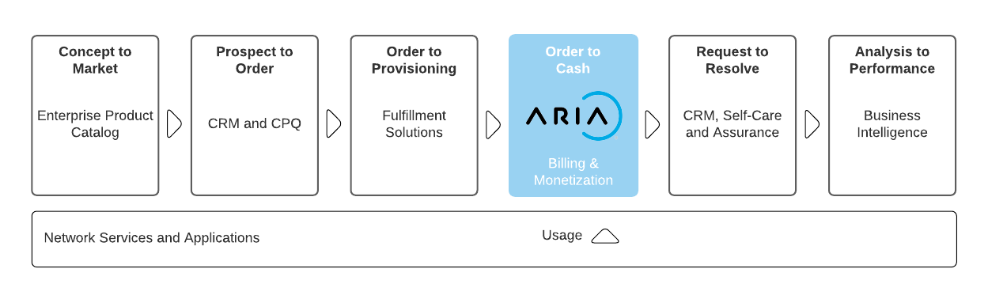
Aria is committed to complying with the TM Forum’s Open API & Open Digital Architecture (ODA) model. It reduces integration costs and timelines for CIOs/CTOs who are actively shifting course to build a more flexible architectural foundation for opportunities driven by 5G/SDN, partnerships and new best-of-breed systems of engagement.

Aria:
- Replaces or augments traditional and best-of-suite operational and business support system (OSS/BSS) architectures that restrict business agility.

- Is 100% configurable (no-code platform) enabling business and IT leaders to get to market fast and at lower cost to entry.

- Operates at web scale and leverages public cloud to change the billing relationship with features such as real-time billing, payment automation and AI/ML routine ingestion to improve time-to-cash and revenue assurance.

- Supports over 100 large CSPs and enterprises across multiple industry verticals, proving it can bill and monetize for any product, for any segment via any channel.

- For more information on Aria for Communication, see https://bit.ly/3FcjDgv

- Overview of Certified API

TMF635 – Usage Management API provides:

- A standardized mechanism for usage management such as the creation, update, retrieval, import and export of a collection of usage records in Aria Crescendo.
- A method for creating and defining usage type or specifications in Aria Crescendo.

The Tables below show the API mandated resource along with mandated operations for conformance.

Usage
Operation | Mandatory/Optional | Comments
GET | M | Response Status Code 200 if successful  Response Status Code 404 if not found
POST | M | Status Code 201 if resource created

Usage Operations

- Create usage
  - This operation creates both rated and un-rated usage records within Aria Crescendo
- Retrieve usage details
  - This operation retrieves a list of usage records from Aria Crescendo
- Retrieve usage details by filters
  - This operation retrieves usage records or collection of usage details based on a variety of filter conditions from Aria Crescendo

UsageSpecification
Operation | Mandatory/Optional | Comments
GET | M | Response Status Code 200 if successful  Response Status Code 404 if not found
POST | M | Status Code 201 if resource created

UsageSpecification Operations

- Create usageSpecification
  - This operation creates usage types within Aria Crescendo
- Retrieve usageSpecification
  - This operation retrieves a list of usage types from Aria Crescendo
- Retrieve usageSpecification by filters
  - This operation retrieves usage types based on a variety of filter conditions from Aria Crescendo

- Architectural View

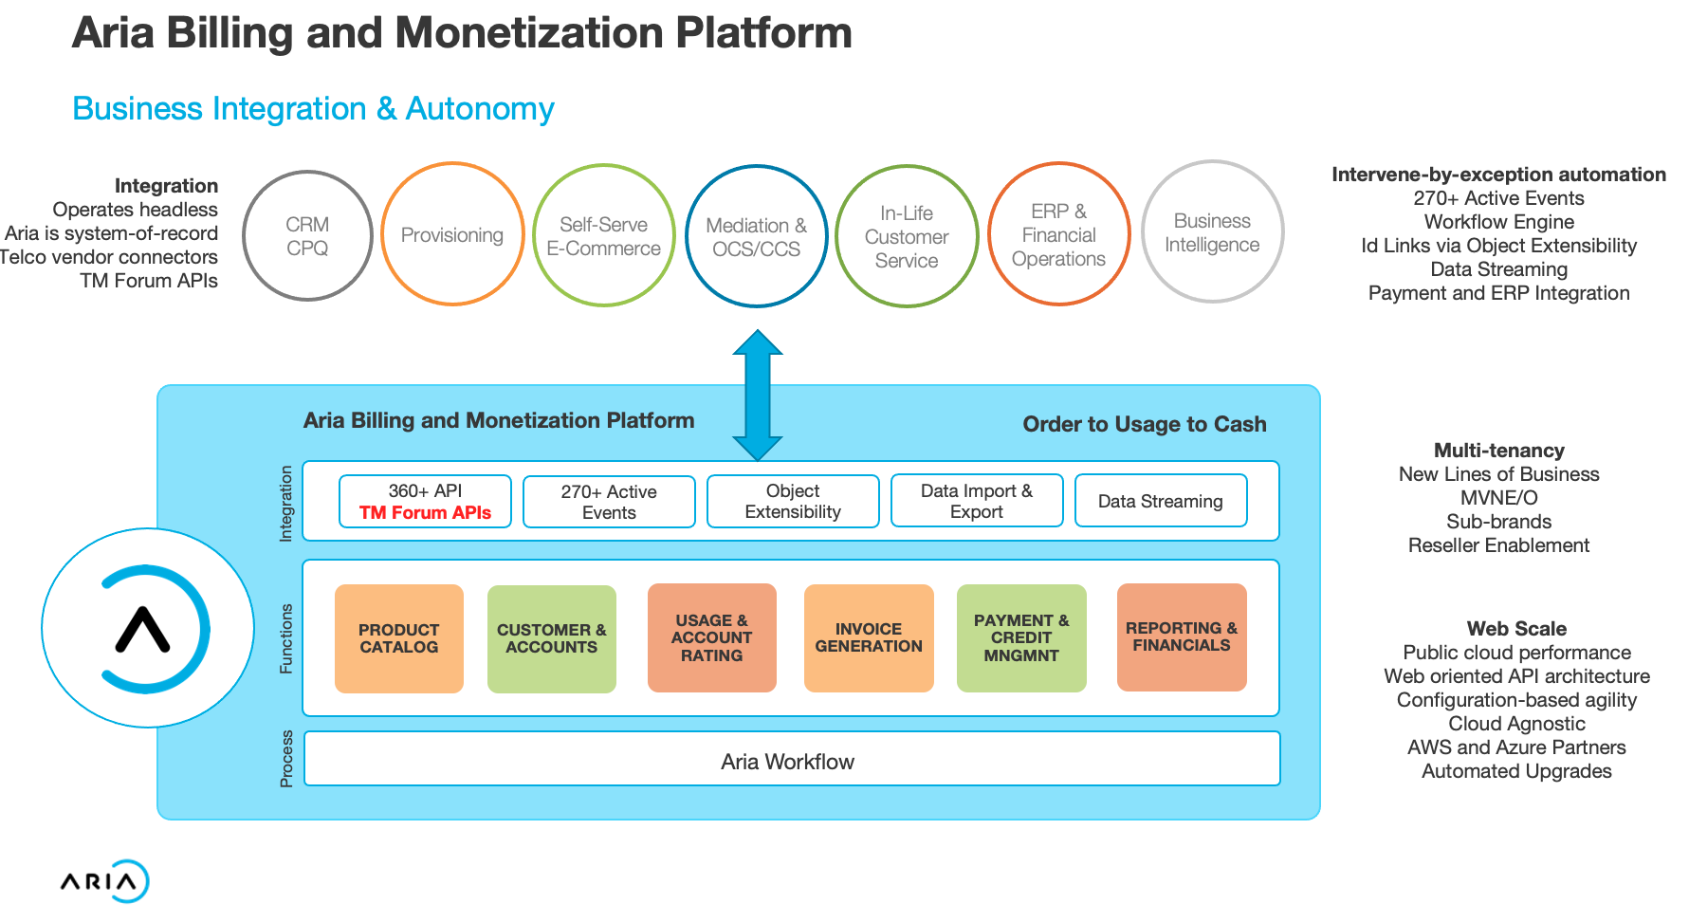

- Test Results

