TM Forum Open APIs
Conformance Certification

Company Name: Aria Systems Inc.

TM Forum Open API Name:
TMF666 Account Management API

TM Forum Open API Release Version: 19.0 / 4.0

Report Date: 18-Nov-2021

- What Product or Solution does your API support?

This API is designed to support Aria’s flagship billing and monetization platform. It is a cloud-native order-to-usage-to-cash solution that is designed to interoperate with a CSP’s IT eco-system using over 360 APIs as end-to-end autonomous billing operation.

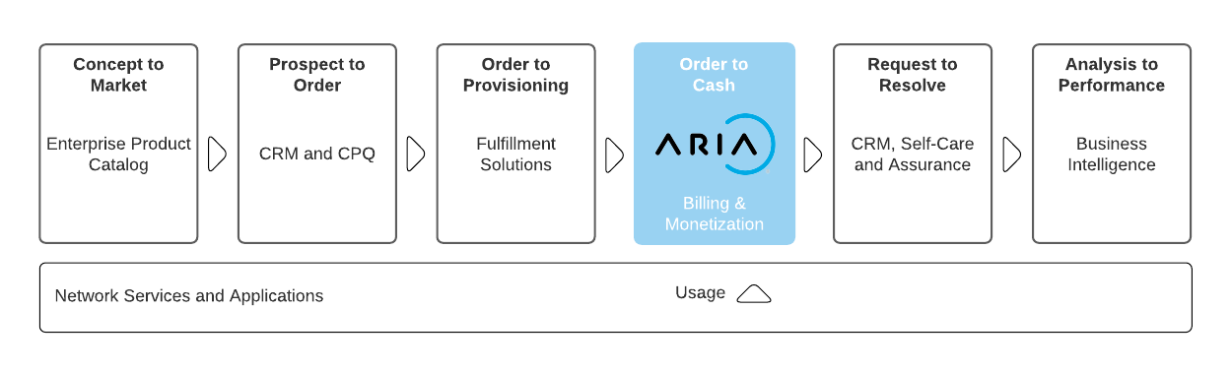
Aria is committed to complying with the TM Forum’s Open API & Open Digital Architecture (ODA) model. It reduces integration costs and timelines for CIOs/CTOs who are actively shifting course to build a more flexible architectural foundation for opportunities driven by 5G/SDN, partnerships and new best-of-breed systems of engagement.

Aria:
- Replaces or augments traditional and best-of-suite operational and business support system (OSS/BSS) architectures that restrict business agility.

- Is 100% configurable (no-code platform) enabling business and IT leaders to get to market fast and at lower cost to entry.

- Operates at web scale and leverages public cloud to change the billing relationship with features such as real-time billing, payment automation and AI/ML routine ingestion to improve time-to-cash and revenue assurance.

- Supports over 100 large CSPs and enterprises across multiple industry verticals, proving it can bill and monetize for any product, for any segment via any channel.

- For more information on Aria for Communication, see https://bit.ly/3FcjDgv

- Overview of Certified API

TMF666 – Account Management API provides:

- A standardized mechanism for the management of party, billing, and settlement accounts, as well as for financial accounting either in B2B or B2B2C context.
- Aria Crescendo uses its extensible fields to distinguish these four types of accounts within the hierarchical account structure.
- A method for creating and retrieval of account information from Aria Crescendo.
- A method for creating and retrieval of billing details from Aria Crescendo and present it in a format and media specified.

The Tables below show the API mandated resource along with mandated operations for conformance.

PartyAccount, BillingAccount, FinancialAccount, SettlementAccount
Operation | Mandatory/Optional | Comments
GET | M | Response Status Code 200 if successful  Response Status Code 404 if not found
POST | M | Status Code 201 if resource created
    - {Party,Billing,Financial,Settlement}Account Operations
- Create an Account
  - This operation creates an Account within Aria Crescendo
- Retrieve Account
  - This operation retrieves a list of Accounts from Aria Crescendo
- Retrieve Accounts by filters
  - This operation retrieves Accounts based on a variety of filter conditions from Aria Crescendo

BillingCycleSpecification
Operation | Mandatory/Optional | Comments
GET | M | Response Status Code 200 if successful  Response Status Code 404 if not found
POST | M | Status Code 201 if resource created
    - BillingCycleSpecification Operations
- Create Billing Cycle Specification
  - This operation creates a Billing Cycle Specification within Aria Crescendo’s rate schedules
- Retrieve Billing Cycle Specification
  - This operation retrieves a list of Billing Cycle Specifications from Aria Crescendo Crescendo’s rate schedules
- Retrieve bill formats by filters
  - This operation retrieves Billing Cycle Specifications based on a variety of filter conditions from Aria Crescendo Crescendo’s rate schedules

BillFormat
Operation | Mandatory/Optional | Comments
GET | M | Response Status Code 200 if successful  Response Status Code 404 if not found
POST | M | Status Code 201 if resource created
    - BillFormat Operations
- Create a bill format
  - This operation creates a bill format within Aria
- Retrieve bill formats
  - This operation retrieves a list of bill formats from Aria
- Retrieve bill formats by filters
  - This operation retrieves bill formats based on a variety of filter conditions from Aria

BillPresentationMedia
Operation | Mandatory/Optional | Comments
GET | M | Response Status Code 200 if successful  Response Status Code 404 if not found
    - billPresentationMedia Operations
- Retrieve Bill Presentation Media
  - This operation retrieves a list of Bill Presentation Media from Aria Crescendo
- Architectural View

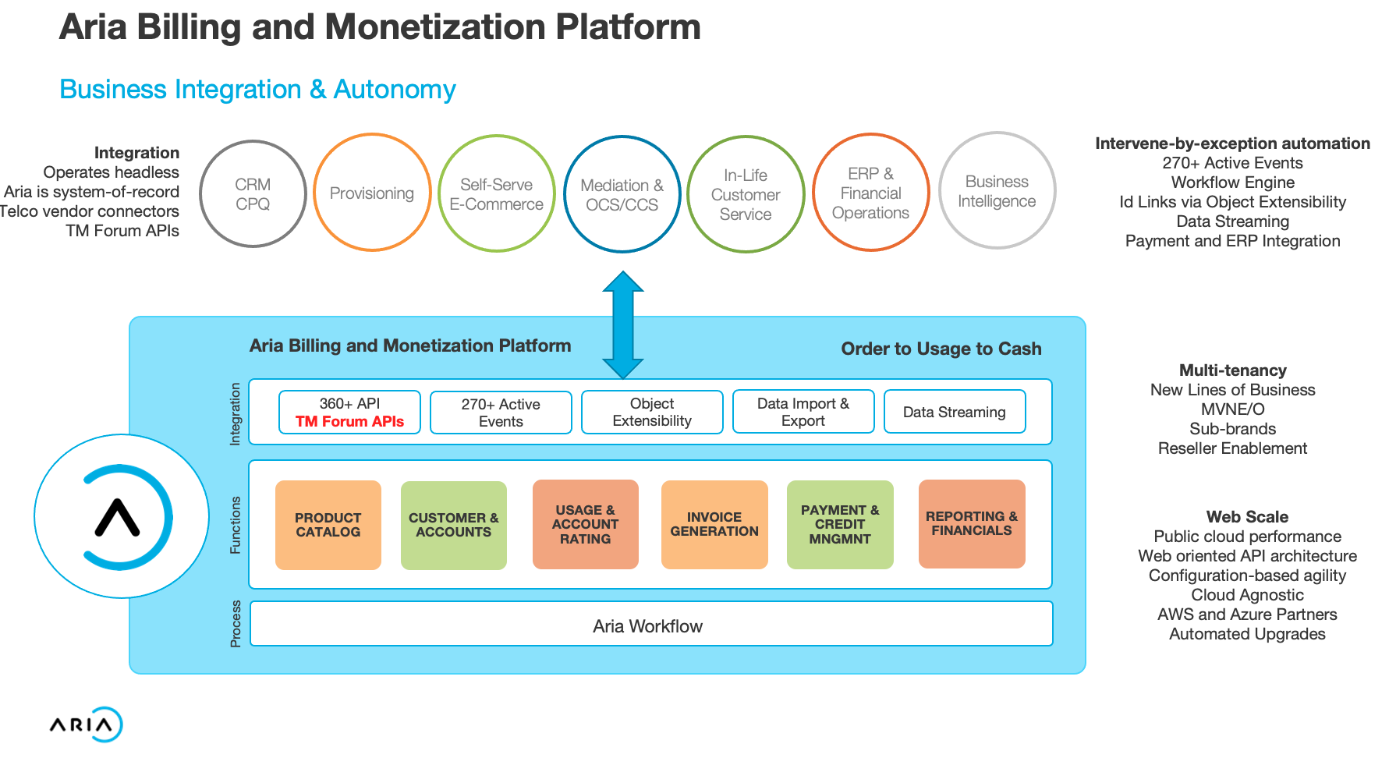

- Test Results

TMF666 HTML Results

