TM Forum Open APIs
Conformance Certification

Company Name: BMC Software

TM Forum Open API Name:
Trouble Ticket – TMF 621

TM Forum Open API Release Version: 19.0 / 4.0

Report Date: 27/10/2021

- What Product or Solution does your API support?

Communications Service Providers (CSPs) are looking to both modernize their services and expand their offerings capabilities. Competitive pressure has never been stronger with traditional companies investing heavily in capital intensive innovations (i.e., 5G, FTTx, etc...) to try and gain MSS and revenue.

Traditional service assurance systems can't keep up with the volume and complexity of business today. Manual processes cannot be used due to the speed needed and certainly cannot even approach the complexity of the network. This lack of Agile and DevOps capabilities, intelligent automation, scale, and flexibility makes it imperative for CSPs to completely reinvent how they approach all aspects of their services.

BMC Helix Service Assurance for CSP, under the BMC Helix for CSP suite, provides critical and intelligent Service Assurance solutions Service Providers require for running their business.

BMC Helix Service Assurance for CSP focuses on the end-to-end trouble ticketing lifecycle and provides:

- Intelligent Service Assurance: Scalable and automated processes to quickly resolve service disruption.
- Trouble Ticketing: Efficiently identify network Troubles from multiple sources, enrich with relevant contextual information to detect, assess, investigate, track, and remediate, reducing operations effort and MTTR while improving visibility and coordination across complex faults and problems.
- Work Order Management: Streamline the creation and management of remedial activities, simplifying and accelerating creation of work orders (through template and enrichment), visualize and proactively track performance across multiple internal and external parties to fix issues faster.
- Network Ops Automation: Automate the creation, enrichment, assessment, and assignment of network troubles, automating key aspects of Network Operations and providing a solid foundation for future automation and delivery of ‘lights out’ Network Operations Centers.
- Service Level Agreements: Visualize and proactively assess impact of troubles on customer services. Easily prioritize remedial activity to minimize SLA disruption.

- Overview of Certified API

BMC Helix Service Assurance for CSP supports ticket management to support manual task orchestration and management.

Actions:
- Create Trouble Ticket
- Update Trouble Ticket
- Retrieve Trouble Ticket

- Architectural View

Business View of BMC Helix Service Assurance for CSP

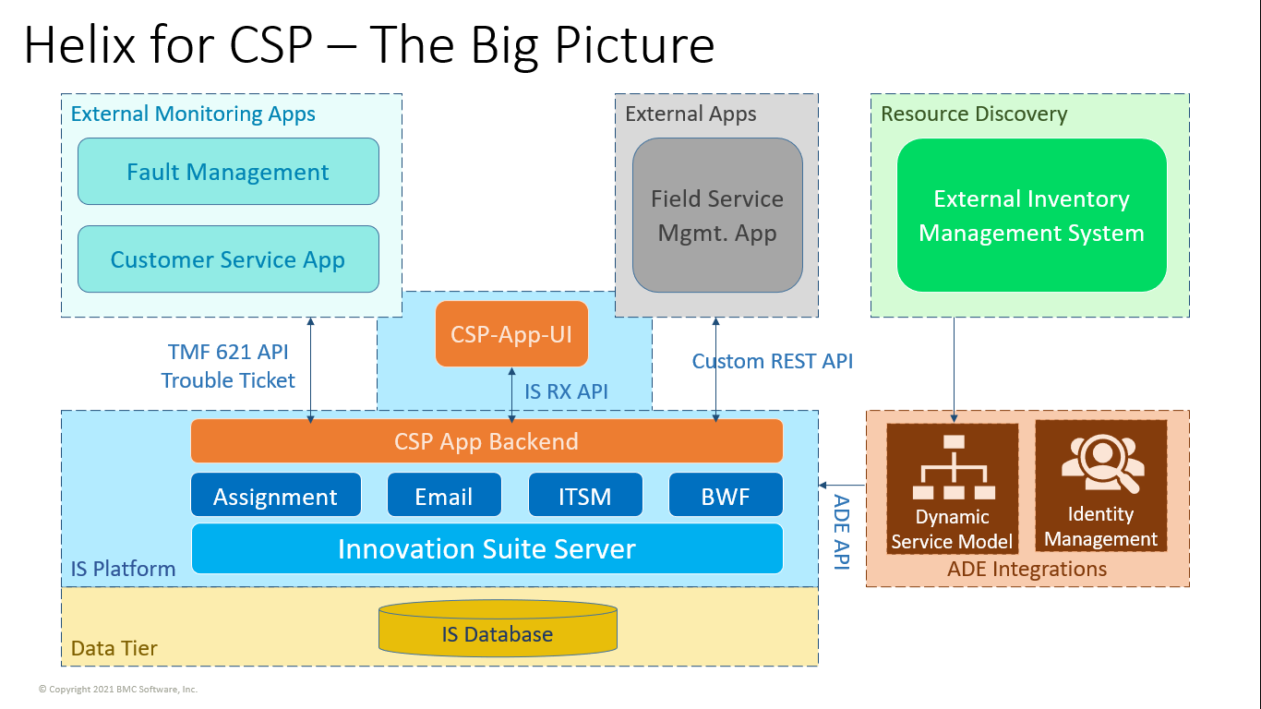

- Test Results

