TM Forum Open APIs
Conformance Certification

Company Name: CSG International

TM Forum Open API Name:
TMF 622 Product Ordering API

TM Forum Open API Release Version: 19.0 / 4.0

Authored by: Frank Wong

Report Date: 19/11/2021

- What Product or Solution does your API support?

The CSG Telflow product provides an industry-leading order management platform to receive, manage and orchestrate product order provisioning. The architecture of the product is designed to abstract between the front-end and back-end, enabling an omni-channel approach to support order submission via a wide variety of technologies.

This approach is supplemented by the TMF 622 Product Ordering API as an interface with the Telflow Northbound B2B suite. By providing a TMF 622 compliant industry standard interface, the upstream channels have a common entry point into the Telflow platform and its underlying order management capabilities. Channels such as an API gateway, customer portal or CRM platform have equal opportunity of integrating onto this TMF 622 product ordering interface to submit orders into Telflow.

The standardization of the Telflow northbound product ordering API to be TMF 622 compliant is invaluable because it enables upstream clients to build their integrations once for interaction with Telflow and then re-use the data mapping across any other present or future order management integration that is also TMF 622 compliant. This reduces cost of on-boarding for Telflow clients as they enjoy the benefits of having an industry standard and tested interface specification to rely on.

The Telflow TMF 622 product order API itself is built using proprietary micro-service technology to provide fundamental out-of-the-box integration features such as message logging, error handling and recovery, and metrics reporting.

CSG is committed to the TM Forum industry standard assets, to the extent that its internal data model is entirely SID aligned; the TMF 622 product ordering API is literal gateway into Telflow order management as the resource model undergoes virtually no transformation as it enters the platform. The Telflow northbound B2B suite ultimately offers a swathe of TMF Open APIs to complement product ordering, including service qualification, product inventory and product catalog, to enable a fully featured product order management experience from any upstream channel.

- Overview of Certified API

The Telflow TMF 622 Product Ordering API enables upstream B2B clients to access the Telflow order management platform programmatically in a TMF standards-aligned manner to submit and track product orders.

# | Resource | API Overview | Operations Supported
1 | Product Order resource | The Product Order resource is used to submit product order requests, instantiating them into Telflow for provisioning.  Once instantiated, the Product Order resources may be retrieved for status tracking, reference, and amendment purposes. | - GET  - PATCH  - POST

- Architectural View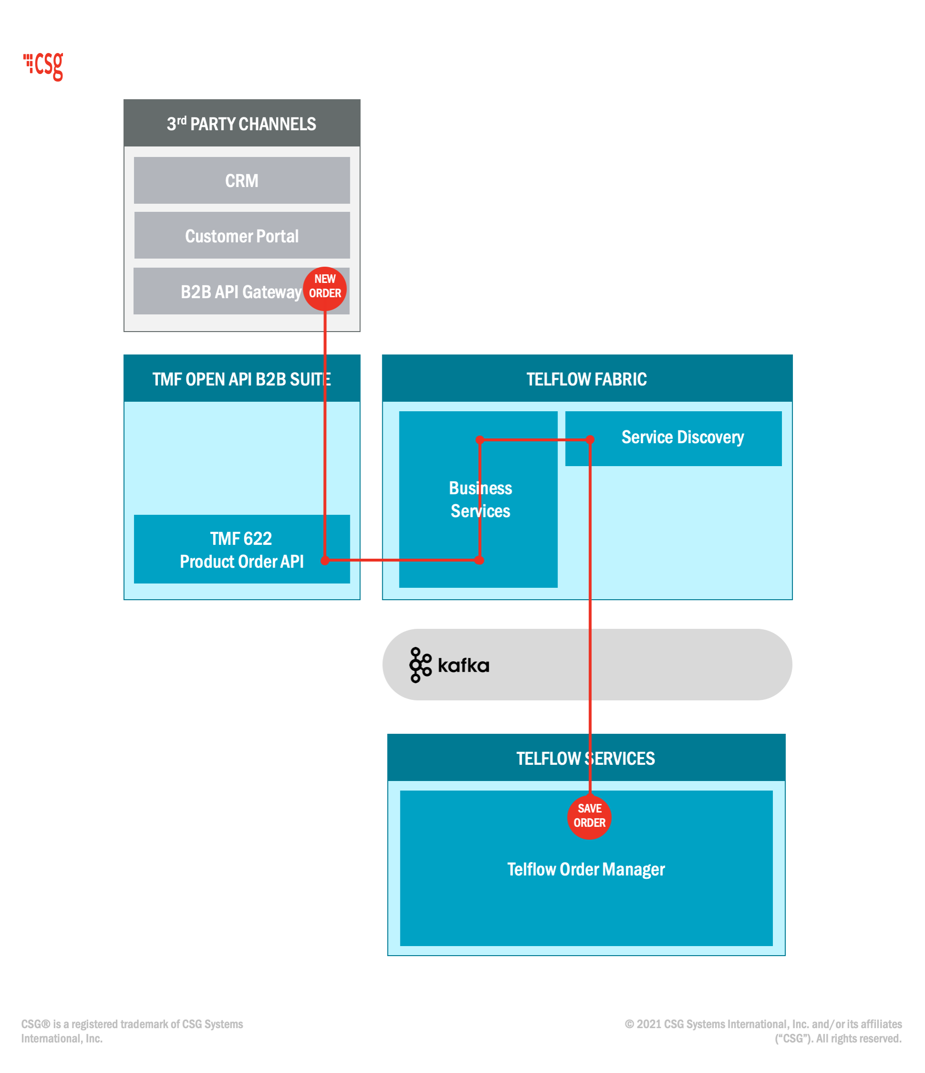
- Test Results

