TM Forum Open APIs
Conformance Certification

Company Name: Inspur Technologies Co. Ltd

TM Forum Open API Name:
TMF620 - Product Catalog Management API

TM Forum Open API Release Version: 21.0 / 4.1

Report Date: 31-10-2021

- What Product or Solution does your API support?

Inspur CRM (Customer Relation Management) support customer-related business process for Telco, accelerate the business innovation. The integrated solution complying TMF standards and applying to various industrial business scenarios. It help operators to improve business management efficiency via qualified and proven technical capabilities of platform, big data, AI and applications.
The Core module manages offering content, including the services (product) that this offering can provide to customer, and price policy which is aligned with Billing System. And also will organize offering using sales catalog, in order to make it more clearly and easily to choose one for customer.
CRM detail architecture function are shown as follow:

- Customer Management
- Product Management
- 360-degree customer view
- Account Management
- Order Management
- Campaign

The Product Catalog Management API provides an interaction interface which the external systems and the third-parties can access such capabilities via this exposed API.

- Overview of Certified API

The catalog management API allows the management of the entire lifecycle of the catalog elements, the consultation of catalog elements during several processes such as ordering process, campaign management, sales management.
Inspur CRM provides Open APIs in line with TM Forum defined specification,
The product catalog management API performs the following operations:
- List Category, Retrieve Category, Create Category, Patch Category and Delete Category
- List Catalog, Retrieve Catalog, Create Catalog, Patch Catalog and Delete Catalog
- List Offering, Retrieve Offering, Create Offering, Patch Offering and Delete Offering
- List Offering Price, Retrieve Offering Price, Create Offering Price, Patch Offering Price and Delete Offering Price
- List Specification, Retrieve Specification, Create Specification, Patch Specification and Delete Specification

- Architectural View
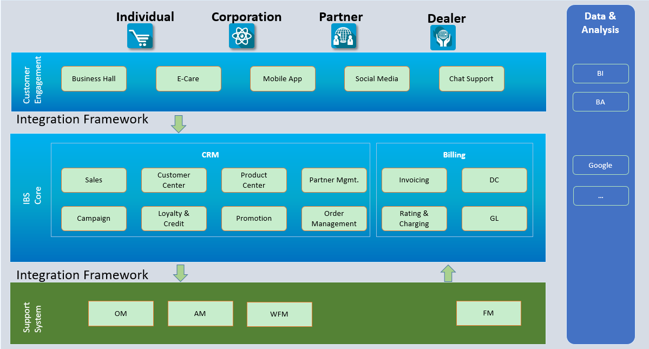

- Test Results

