TM Forum Open APIs
Conformance Certification

Company Name: Inspur Technologies Co. Ltd

TM Forum Open API Name:
TMF621 - Trouble Ticket API

TM Forum Open API Release Version: 19.0 / 4.0

Report Date: 16-10-2021

- What Product or Solution does your API support?
SDM provides centralized operation and maintenance workflow management for Telecom operator, the main function consists of trouble tickets, Authority Management, etc.
The Trouble Ticket API provides an interaction interface which the external systems and the third-parties can access such capabilities via this exposed API.

- Overview of Certified API
The Trouble Ticket API provides a standardized client interface to Trouble Ticket Management Systems for creating, tracking and managing trouble tickets as a result of an issue or problem identified by a customer or another system.
Inspur SDM provides Open APIs in line with TM Forum defined specification,
The Trouble Ticket API performs the following operations:
- List Trouble Ticket, Retrieve Trouble Ticket, Create Trouble Ticket, Patch Trouble Ticket and Delete Trouble Ticket

- Architectural View
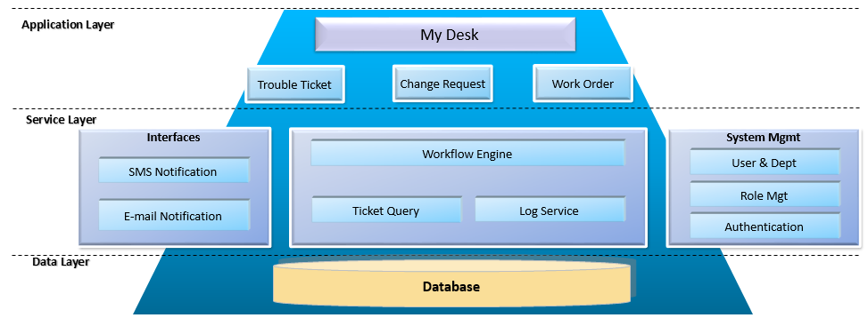
- Test Results

