TM Forum Open APIs
Conformance Certification

Company Name: Inspur Technologies Co. Ltd

TM Forum Open API Name:
TMF622 - Product Ordering API

TM Forum Open API Release Version: R19.0.1 / v4.0.0

Report Date: 16-10-2021

- What Product or Solution does your API support?

Inspur CRM (Customer Relation Management) support customer-related business process for Telco, accelerate the business innovation. The integrated solution complying TMF standards and applying to various industrial business scenarios. It help operators to improve business management efficiency via qualified and proven technical capabilities of platform, big data, AI and applications.
The Core module Product Ordering is used to manage the entire process from order creation to service fulfillment.
CRM detail architecture function are shown as follow:
- Customer Management
- Product Management
- 360-degree customer view
- Account Management
- Order Management
- Campaign

The Product Ordering API provides an interaction interface which the external systems and the third-parties can access such capabilities via this exposed API.

- Overview of Certified API

A product order is created based on a product offer that is defined in a catalog. The product offer identifies the product or set of products that are available to a customer, and includes characteristics such as pricing, product options and market. This API provide a task based resource to request order cancellation.

Inspur CRM provides Open APIs in line with TM Forum defined specification,
The product ordering API performs the following operations:
- List Product Order, Retrieve Product Order, Create Product Order, Patch Product Order and Delete Product Order

- Architectural View
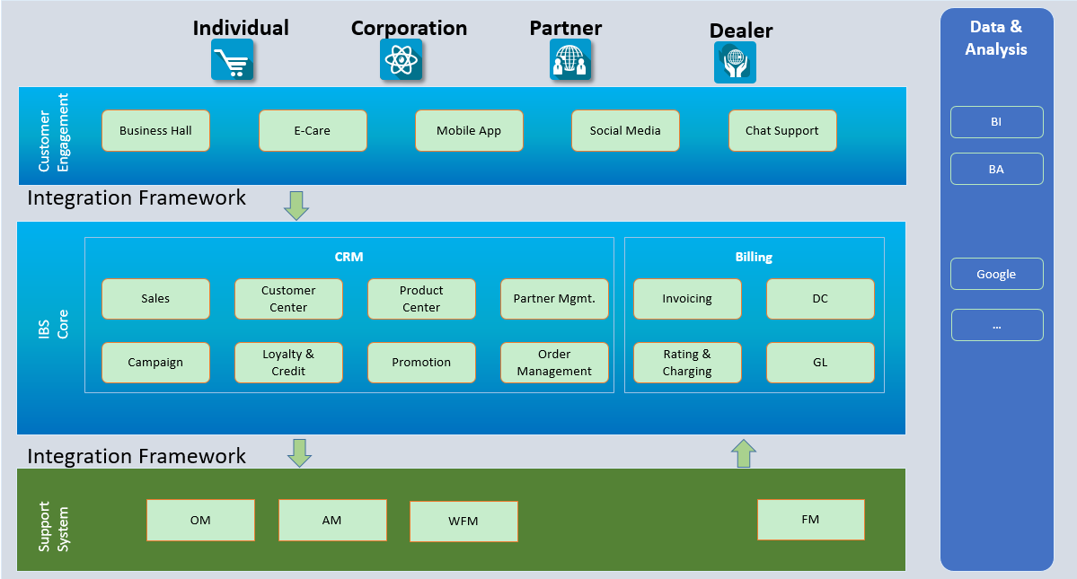

- Test Results

