TM Forum Open APIs
Conformance Certification

Company Name: Inspur Technologies Co. Ltd

TM Forum Open API Name:
TMF651 - Agreement Management API

TM Forum Open API Release Version: 19.0 / 4.0

Report Date: 16-10-2021

- What Product or Solution does your API support?

Inspur Partner Relationship Management provides the necessary functionality to support partner definition and hierarchy management, revenue sharing arrangements, agreements between the service provider and the partner, settlement processes, and reconciliation processes. Partner Relationship Management provides the necessary functionality to manage the lifecycle of the relationship between a partner and the service provider.

Inspur PRM have four major Modules which are Partner Management, Agreement & Policy, Commission & Settlement and KPI&SLA. And also provide interfaces to 3rd Party System

The Agreement API provides an interaction interface which the external systems and the third-parties can access such capabilities via this exposed API.

- Overview of Certified API

The Agreement API provides a standardized mechanism for managing agreements, especially in the context of partnerships between partners.

Inspur PRM provides Open APIs in line with TM Forum defined specification,
The Agreement API performs the following operations:
- List Agreement, Retrieve Agreement, Create Agreement, Patch Agreement and Delete Agreement
- List Agreement Specification, Retrieve Agreement Specification, Create Agreement Specification, Patch Agreement Specification and Delete Agreement Specification.

- Architectural View

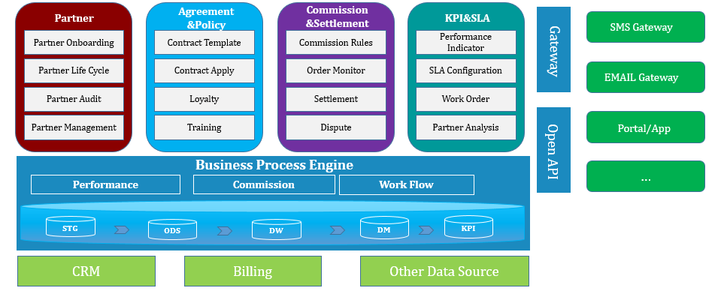

- Test Results

