TM Forum Open APIs
Conformance Certification

Company Name: Inspur Technologies Co. Ltd

TM Forum Open API Name:
TMF663 - Shopping Cart API

TM Forum Open API Release Version: 19.0 / 4.0

Report Date: 16-10-2021

- What Product or Solution does your API support?

Inspur CRM (Customer Relation Management) support customer-related business process for Telco, accelerate the business innovation. The integrated solution complying TMF standards and applying to various industrial business scenarios. It help operators to improve business management efficiency via qualified and proven technical capabilities of platform, big data, AI and applications.
Shopping cart supports purchase of both tangible and intangible goods and service (e.g. handset, telecom network service).
CRM detail architecture function are shown as follow:
- Customer Management
- Product Management
- 360-degree customer view
- Account Management
- Order Management
- Campaign

The Shopping Cart API provides an interaction interface which the external systems and the third-parties can access such capabilities via this exposed API.

- Overview of Certified API

Inspur CRM provides Open APIs in line with TM Forum defined specification,
The Shopping Cart API performs the following operations:
- List Shopping Cart, Retrieve Shopping Cart, Create Shopping Cart, Patch Shopping Cart and Delete Shopping Cart

- Architectural View

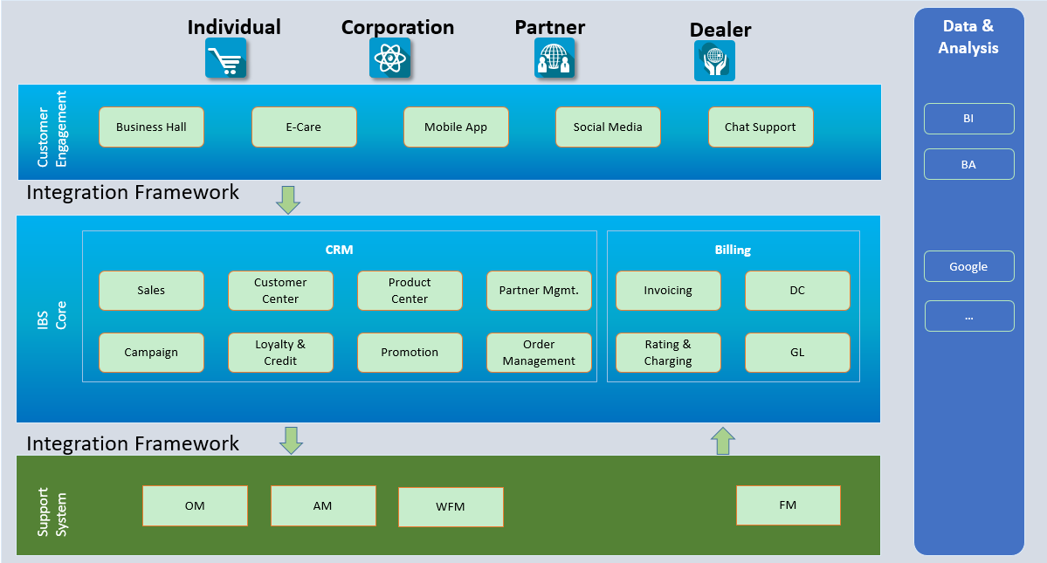

- Test Results

