TM Forum Open APIs
Conformance Certification

Company Name: Inspur Technologies Co. Ltd

TM Forum Open API Name:
TMF699 - Sales Management API

TM Forum Open API Release Version: R19.0 / 4.0

Report Date: 16-10-2021

- What Product or Solution does your API support?

Inspur CRM (Customer Relation Management) support customer-related business process for Telco, accelerate the business innovation. The integrated solution complying TMF standards and applying to various industrial business scenarios. It help operators to improve business management efficiency via qualified and proven technical capabilities of platform, big data, AI and applications.

CRM detailed architecture function is shown as follows:

- Customer Management
- Product Management
- 360-degree customer view
- Account Management
- Order Management
- Campaign

The Sales API provides an interaction interface which the external systems and the third-parties can access such capabilities via this exposed API.

- Overview of Certified API

Sales API provides interfaces for Sales Lead, Sales Opportunity, Sales Quote and the other management capabilities to support the sales activities to build relationship with the prospect customer who could be a person or organization that has an interest in the goods and/or services and possibly become the actual customers with one or more Subscriptions.

Inspur CRM provides Open APIs in line with TM Forum defined specification,
The Sales API performs the following operations:
- List Sales Lead, Retrieve Sales Lead, Create Sales Lead, Patch Sales Lead and Delete Sales Lead

- Architectural View
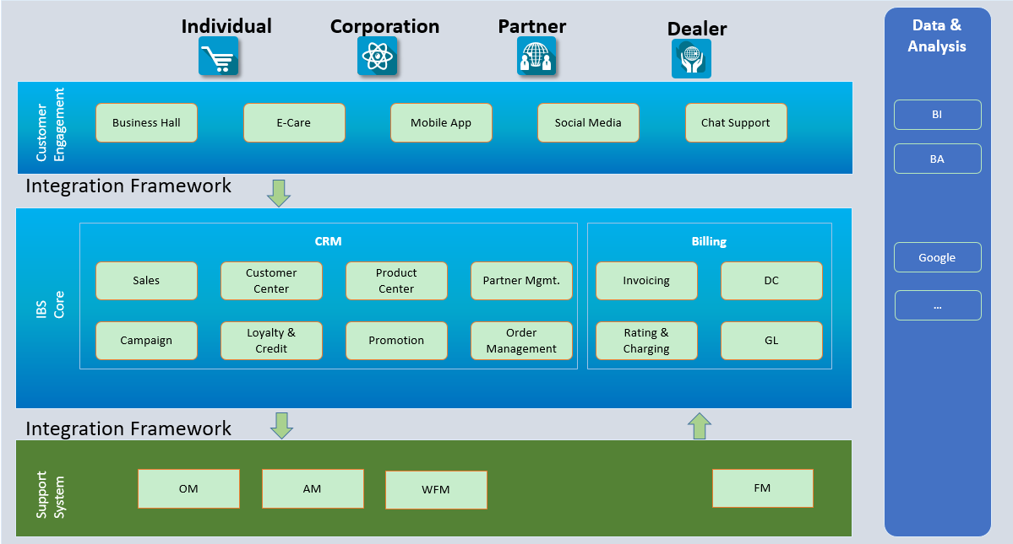

- Test Results

