TM Forum Open APIs
Conformance Certification

Company Name: ZIRA Ltd.

TM Forum Open API Name:
TMF620 Product Catalog Management API

TM Forum Open API Release Version: 21.0 / 4.1

Report Date: 03/11/2021

- What Product or Solution does your API support?

ZIRA Product Catalog enables the management of entire product lifecycle, from the design, development, and activation to retirement phase. This includes consistent and controlled propagation of relevant product data across all environments through embedded versioning control and release management capabilities.

Real-time visibility of product lifecycle and performance combines people, projects, workflows, technology and data into a strategic approach for developing and managing products and their lifecycles.

Providing CSPs greater control of product data, allows product development teams not only to accelerate their design change review cycle but also to facilitate the transfer of design information to development and production. These operational improvements also help bring new products into the market faster and allow CSPs to capture more revenue earlier.

Product Catalog APIs are provided for all external functionalities related to the PC that can be used by any other system, whether just retrieving/fetching data, specific sales support functions and/or product catalog management capabilities.

- Overview of Certified API

The ZIRA Product Catalog Management API is functionality of the ZIRA Product Catalog product that provides standardized mechanism for lifecycle managing of product catalog configuration.

ZIRA Product Catalog Management API is compliant with TMF620 Product Catalog Management specification and offers interface to create, update, query and cancel product catalog configuration resources.

# | Resource | API Overview | Operations Supported
1 | /productOffering | Product Catalog API performs the following operations on the product offering resource:  - Retrieve a product offering or a collection of product offerings depending on filter criteria.  - Partial update of a product offering (including updating rules).  - Create a product offering (including default values and creation rules).  - Delete a product offering. | - GET  - PATCH  - POST  - DELETE
2 | /productSpecification | Product Catalog API performs the following operations on the product specification resource:  - Retrieve a product specification or a collection of product specifications depending on filter criteria.  - Partial update of a product specification (including updating rules).  - Create a product specification (including default values and creation rules).  - Delete a product specification. | - GET  - PATCH  - POST  - DELETE
3 | /productOfferingPrice | Product Catalog API performs the following operations on the product offering price resource:  - Retrieve a product offering price or a collection of product offering prices depending on filter criteria.  - Partial update of a product offering price (including updating rules).  - Create a product offering price (including default values and creation rules).  - Delete a product offering price. | - GET  - PATCH  - POST  - DELETE

- Architectural View

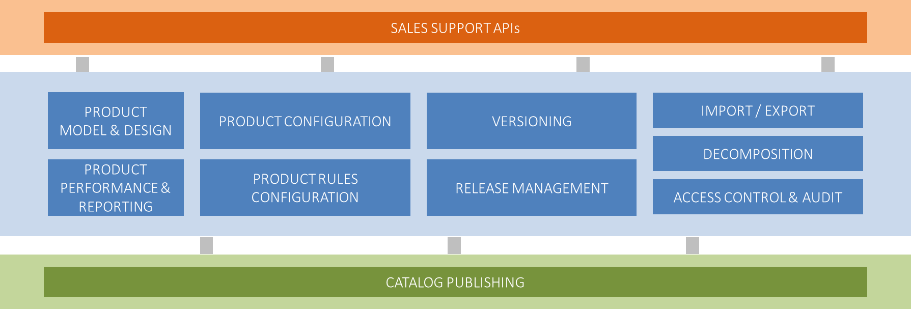

- Test Results

