TM Forum Open APIs
Conformance Certification

Company Name: ZIRA Ltd.

TM Forum Open API Name:
TMF622 Product Ordering API

TM Forum Open API Release Version: 19.0 / 4.0

Report Date: 27/10/2021

- What Product or Solution does your API support?

ZIRA Unified Order Management is an end-to-end integrated ordering system that automates and accelerates the ordering process providing to customers’ flexible and efficient concept of one-stop shopping.

It is all about speed and performance. It can integrate quickly into the environment speeding up the delivery of existing and new product offerings to customers, guiding orders from start to finish – orchestrating order decomposition, routing, status tracking, business-rule validation, provisioning, activation and billing.

The system handles orders from various channels with configurable workflows.

The solution offers variety of functions for order data handling and supports sales process of any type of CSP service and line of business, from data/IP, wireline, and mobile, to voice, messaging services and IoT.

ZIRA UOM is a comprehensive next-generation order management solution which modernizes business process and increases customer retention bringing up new emerging services by efficiently reduced operating costs and time-to-market.

As it utilizes standard APIs, the solution can be fully integrated with legacy systems and is combining both simple services, as well as convergent services with highly complex order handling processes helping CSPs rapidly build, integrate and automate order processing within desired environment.

- Overview of Certified API

The ZIRA Product Ordering API is functionality of the core ZIRA Unified Order Management product that provides standardized mechanism for lifecycle managing of product orders.

ZIRA Product Ordering API is compliant with TMF622 Product Ordering specification and offers interface to create, update, query and cancel product orders.

# | Resource | API Overview | Operations Supported
1 | /ProductOrder | A Product Order is a type of order which can be used to place an order between a customer and a service provider or between a service provider and a partner and vice versa.  Main Order Items (aka order lines) attributes are the ordered offering and product characteristics with the related action to be performed (e.g. add or delete the products), state, location information for delivery, order item price and price alteration. | - GET  - PATCH  - POST  - DELETE

- Architectural View

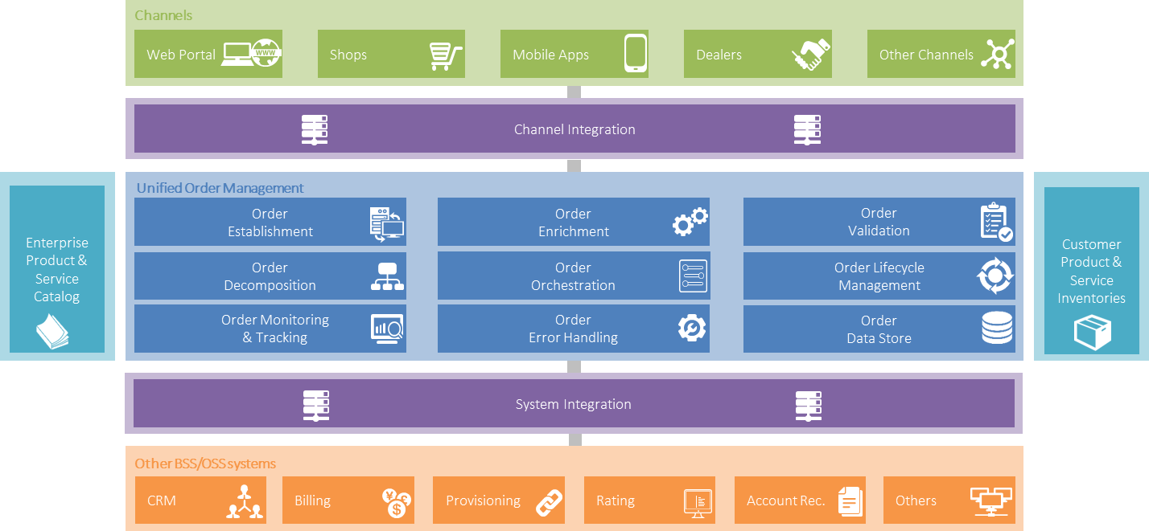

- Test Results

