TM Forum Open APIs
Conformance Certification

Company Name: ZIRA Ltd.

TM Forum Open API Name:
TMF638 Service Inventory Management API

TM Forum Open API Release Version: 20.5. / 4.0

Report Date: 11/11/2021

- What Product or Solution does your API support?

Essentially, ZIRA Service Inventory keeps the collection of service instances such as mobile or TV subscription that allow an organization to manage service lifecycle and offer greater quality, speed and performance to its customers at reasonable prices.

The Service Inventory API can be called by the Service Order Management to create a new service instance/update an existing service instance in the Service Inventory.

The Service Inventory API can be used to query the service instances for a customer via Self Service Portal or the Call Centre operator can query the service instances on behalf of the customer while a customer may have a complaint or a query.

The intent of this API is to provide a consistent/standardized mechanism to query and manipulate the Service inventory.

- Overview of Certified API

The ZIRA Service Inventory Management API is functionality of the core ZIRA Unified Order Management product that provides standardized mechanism for lifecycle managing of service instances.

ZIRA Service Inventory Management API is compliant with TMF638 Service Inventory Management API specification and offers interface to create, update, query and cancel service instances.

# | Resource | API Overview | Operations Supported
1 | /service | Service is an abstract base class for defining the Service hierarchy. All Services are characterized as either being possibly visible and usable by a Customer or not. This gives rise to the two subclasses of Service: CustomerFacingService and ResourceFacingService. | - GET  - PATCH  - POST  - DELETE

- Architectural View

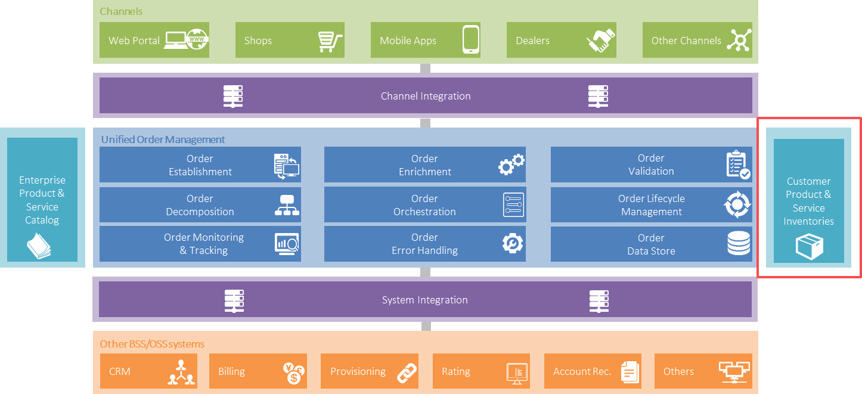

- Test Results

