TM Forum Open APIs
Conformance Certification

Company Name: ZIRA Ltd.

TM Forum Open API Name:
TMF641 Service Ordering Management API

TM Forum Open API Release Version: 21.0 / 4.1

Report Date: 27/10/2021

- What Product or Solution does your API support?

ZIRA’s Service Order Management is a constituent of enterprise catalog-driven ordering management suite.

The main objective of the ZIRA SOM solution is to push the commission of service orders quickly towards the communication enablers considered as the service technological building blocks.

ZIRA SOM’s flexible and standards-based architecture supports seamless interoperability with both legacy and commercial applications within the BSS/OSS ecosystem and empowers service providers to customize and localize the environment to meet their specific business needs, rules, policies, and procedures.

ZIRA SOM utilizes standard APIs to effectively integrate with any Customer Order Management system as well as with other north-bound and south-bound systems of the Telco landscape, so it can effectively maintain up-to-date characteristics of the service orders.

- Overview of Certified API

The ZIRA Service Ordering Management API is functionality of the core ZIRA Service Order Management product that provides standardized mechanism for lifecycle managing of service orders.

ZIRA Service Ordering Management API is compliant with TMF641 Service Ordering Management specification and offers interface to create, update, query and cancel service orders.

# | Resource | API Overview | Operations Supported
1 | /ServiceOrder | A service order will describe a list of service order items. A service order item references an action on an existing or future service. By service we designed Customer Facing Service (CFS) as well as Resource Facing Service (RFS). | - GET  - PATCH  - POST  - DELETE

- Architectural View

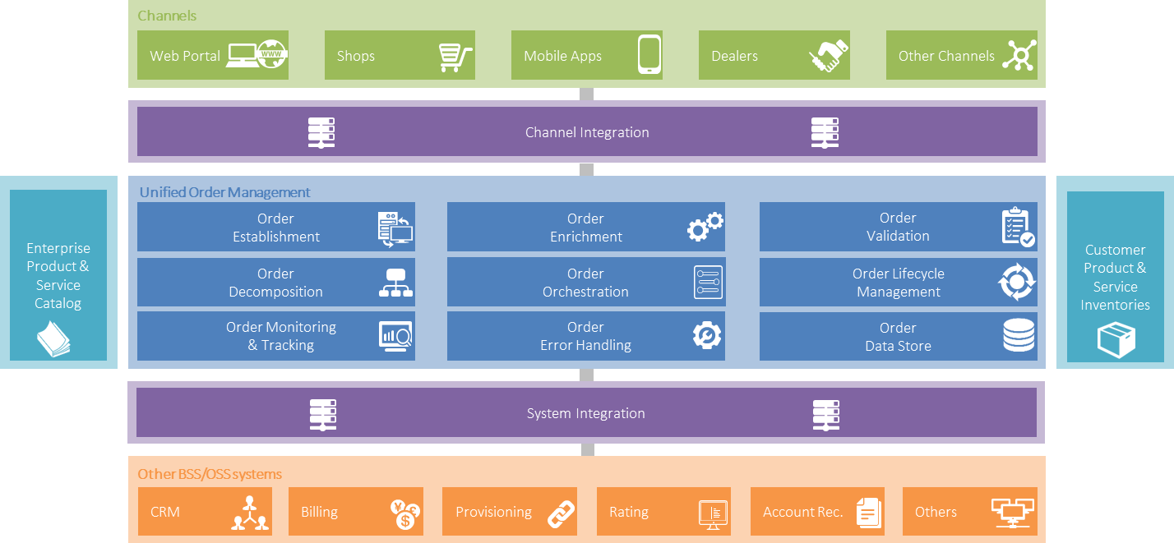

- Test Results

