Conformance Certification
JIO B2C System - ODA-C – Jio Meet/Events
Company: Jio Infocomm Limited
Conformance Artefact Name: JIO B2C System - ODA-C – Jio Meet/Events
Conformance Type: Solution Conformance
eTOM/SID Version: 24.0
Assessment Completion Date: July 2025
Detailed Certification Report: https://

General Overview

This document provides details of Jio Meet / Events, against the following ODA Core Frameworks:

- Business Process Framework (eTOM) version 24.0.
- Information Framework (SID) version 24.0.
The assessment included a review of the methodology approach to process and information modeling, respectively against the TM Forum’s Business Process Framework (eTOM) and the Information Framework (SID) according to the specific processes and entities submitted in scope for the Assessment.

For more information on of Jio Meet / Events, please contact:

Name: Smruti TN
Position: Head of business strategy
Email: smruti.tn@ril.com

Name: Rohit Sharma
Position: Product Lead
Email: rohit61.sharma@ril.com

Name: Sai Krishna Teja
Position: Customer success Lead.
Email: sai.nadimpalli@ril.com

For any additional information on this ODA Conformance Certification Report, please contact TM Forum at: conformance@tmforum.org.
.

Solution Functionality / Capability
JioEvents – Powering Seamless & Scalable Events
- All-in-One Event Platform: Manages virtual, hybrid, and large-scale events with tools like SIP support, spotlight control, ticketing, and analytics.
- Engaging Experiences: Boosts interactivity through live chat, polls, reactions, flashcards, and ticker text.
- Immersive Branding: Offers custom welcome pages, pre-set themes, banners, and watermark logos for brand consistency.
- Gamified Engagement: Includes contests, leaderboards, social walls, booths, and more to keep audiences hooked.
- AI-Powered Features: Uses Gen-AI to create 3D lobbies, avatars, immersive event pages, and post-event summaries.
- JioEvents Studio: Enables virtual production setups for shows, podcasts, interviews, and training events.
- Flexible Layouts: Studio blueprints help design dynamic event formats like polls, newsrooms, or halo presence.
- Proven & Scalable: Built for scale with happy customers and robust tech infrastructure.
JioMeet – India's Secure & Scalable Video Collaboration Platform
- Two Powerful Offerings:
  - JioMeet App – Standalone video conferencing for everyday use
  - JioMeet Platform – CPaaS model with SDKs & APIs to embed video in any app or platform
- Enterprise-Grade Features:
  - Real-time voice translation
  - Watchparty integrations (JioTV, JioCinema)
  - HD video, screen sharing, and meeting recording
- Tailored for India:
  - Works on low bandwidth and older devices
  - Multilingual, intuitive interface for mass adoption
  - 100% WCAG Level A accessibility compliance
- Competitive Edge:
  - Cost-effective SDKs and white-label support
  - Pre-built templates with out-of-box recording and tech support
  - Listed on GeM and already used in government & enterprise sectors
- Recognition & Reach:
  - Showcased globally (MWC Barcelona, IMC, GPAI)
  - Awarded for AI-powered skill development and innovation
- Developer Friendly:
  - SDKs available on GitHub & NPM for Android, iOS, and Web
  - Scalable infrastructure with deep Jio network integrationKey Features:

Architecture
Jiomeet Architecture:
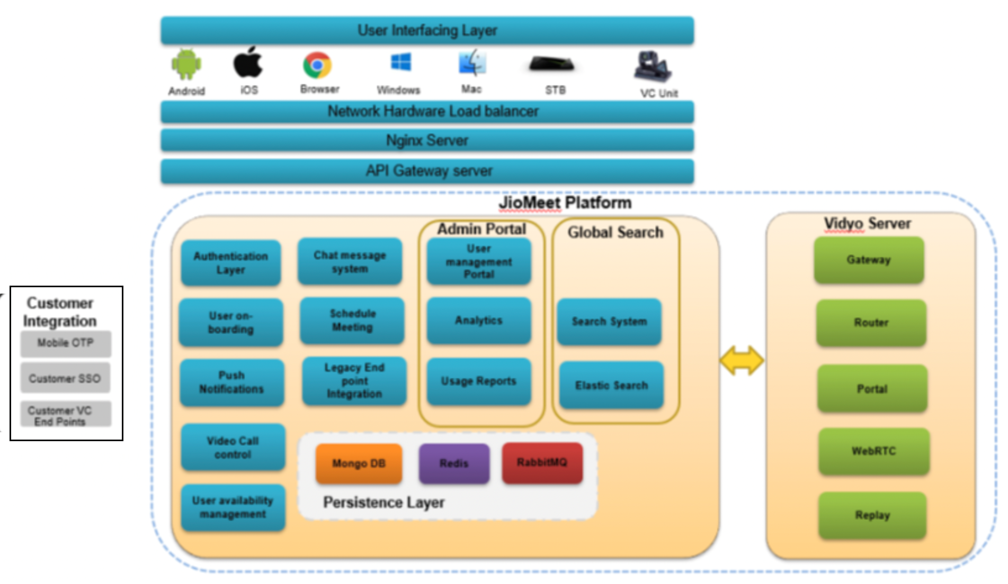
Jio Meet/Events –Technical Architecture Diagram

eTOM and SID Certification Scope
The following two figures represent the Business Process Framework (eTOM) Level 2 processes and the Information Framework (SID) ABEs that were presented in scope for conformance certification.

Business Process Framework (eTOM) – Jio Meet/Events – Conformance Scope
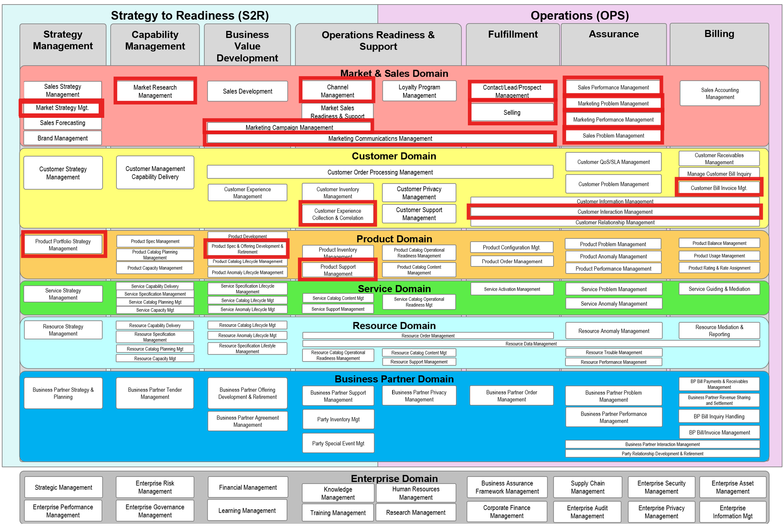
Process coverage for Jio Meet/Events - Conformance Certification

Information Framework (SID) Assessment - ABE Scope
Information Framework (SID) – Jio Meet/Events – Conformance Footprint
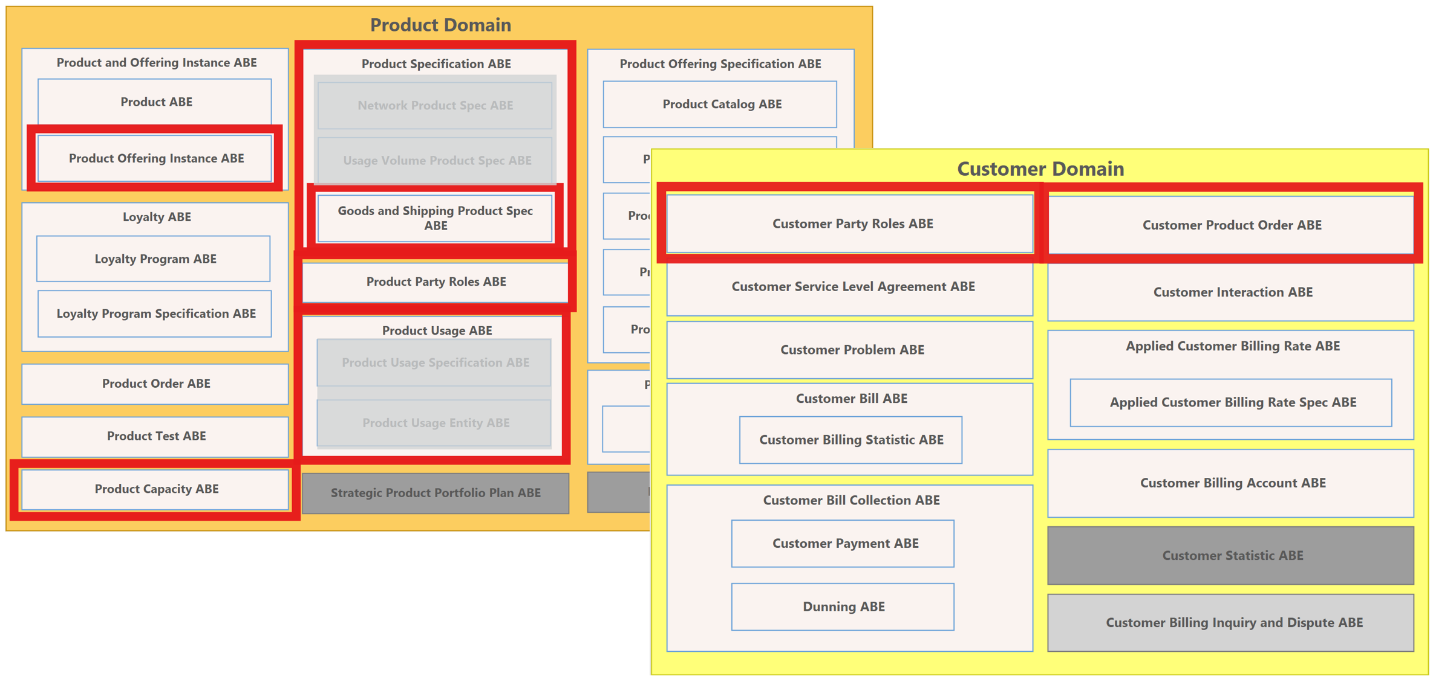
Level 1 ABEs - SID coverage Jio Meet/Events - Conformance Certification

